**Project 2**

**Domain-Specific Data Engineering**

**Retail Inventory Management and Sales Forecasting**

**Step 1: Define the Scope**

1. **Business Objective:** Optimize inventory management and sales forecasting.
2. **Data Sources:**

* Sales transactions (customer purchases, product details, quantities, timestamps)
* Inventory logs (stock levels, product movements, dates)
* Customer data (demographics, purchase history, preferences)

1. **Success Metrics/Goal:** Optimize inventory levels to reduce stockouts by 20% within the next 12 months, while improving sales forecast accuracy by 15%.

**Step 2: Design the Data Pipeline:**

1. **Data Ingestion:**

* **Sales transactions: Through data transfer via linked service to onprem network for batch processing (on-premises to Azure SQL data base)**
* **Inventory logs: Copy activity, source: Synapse Warehouse, sink: Azure SQL Database**
* **Customer data: Through Database connectors, Notebook Activity, Source: Azure database for MySQL (Azure data studio), sink: Azure SQL database**

1. **Data Storage: Azure SQL Database**
2. **Data Transformation: Pyspark (notebook)**
3. **Data Warehousing and Analytics:** **Snowflake, Power BI**

**Step 3. Implementation and Monitoring: Adf monitor**

**Step 4: Advanced Considerations:**

1. **Data Format Exploration:** (CSV vs. Parquet) comparisons in data bricks
2. **Data Pipeline Automation:** No real time data implemented in this project
3. **Medallion Architecture:** Implemented in data bricks
4. **Distribution Indexing:** Used indexing and table distribution on the source tables

**Implementation of project:**

1. **Data Ingestion:**

* **Sales transactions: Through copy activity transfer via linked service to on-premises (batch processing) to Azure SQL data base)**

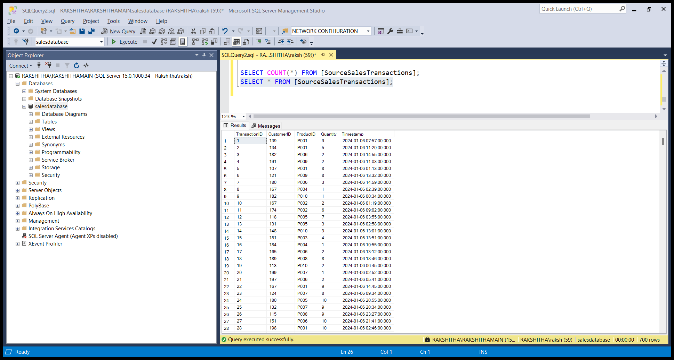

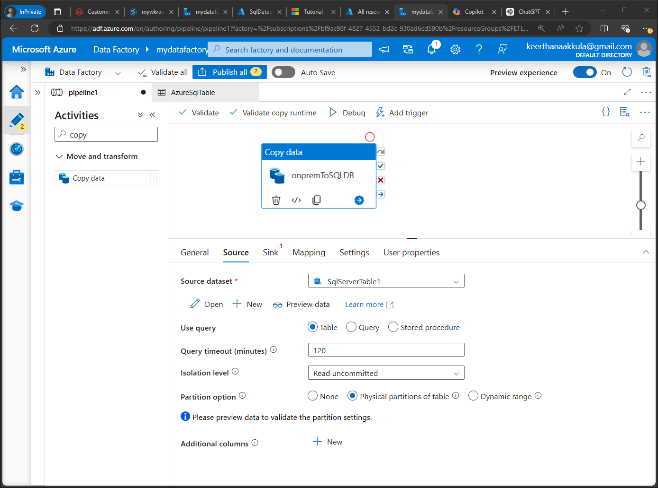

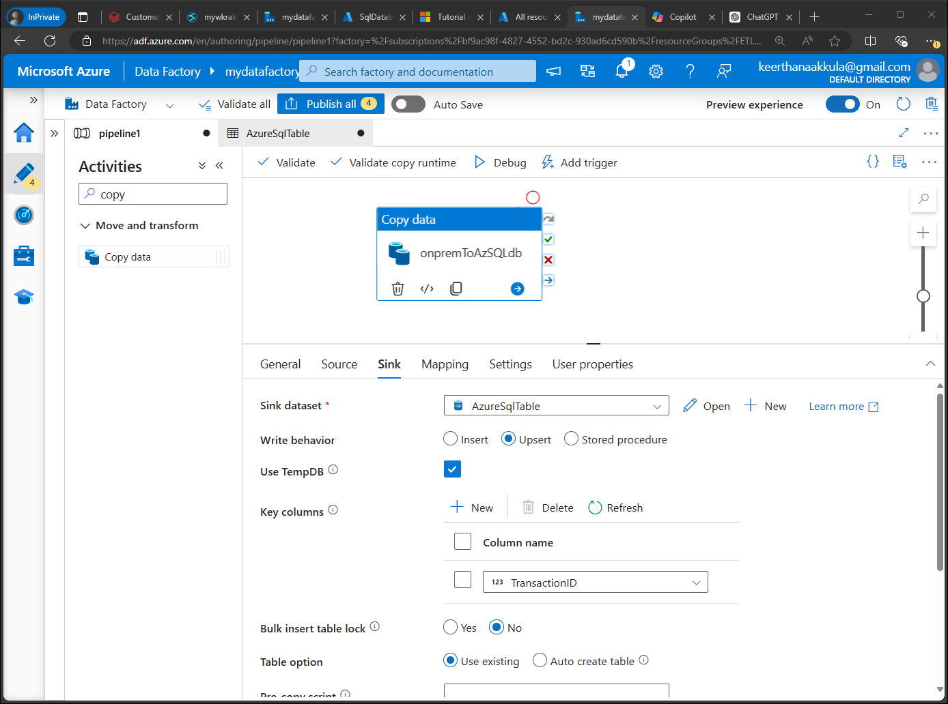

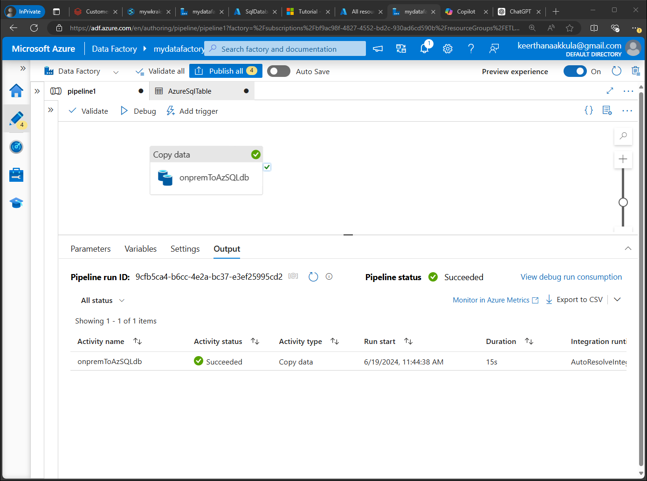

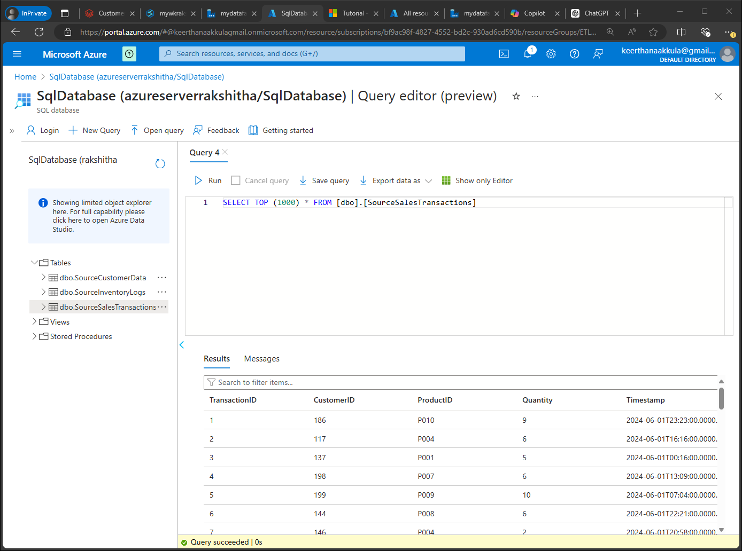

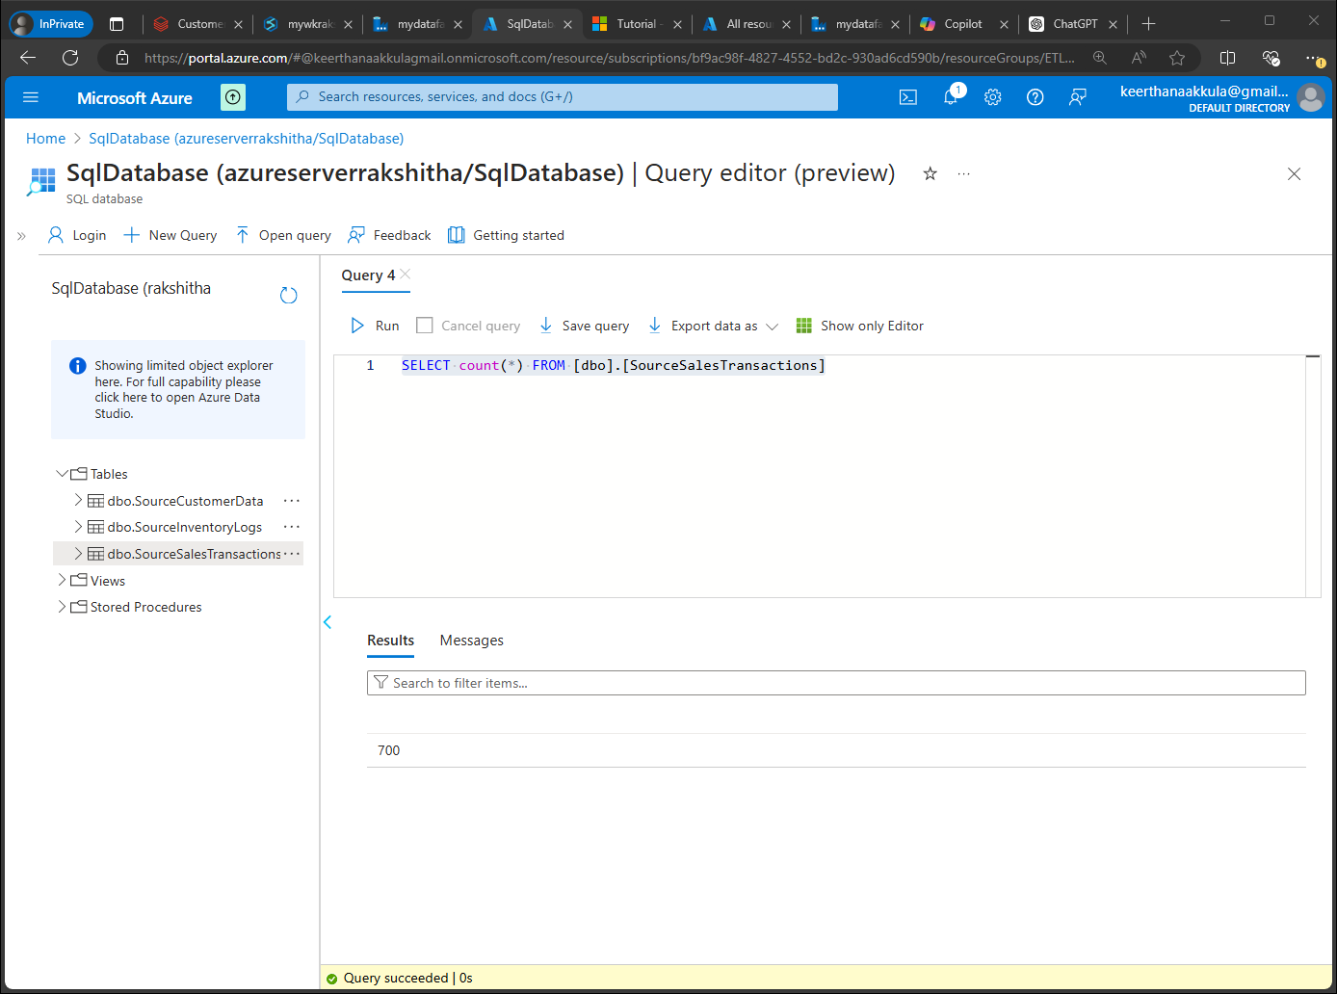

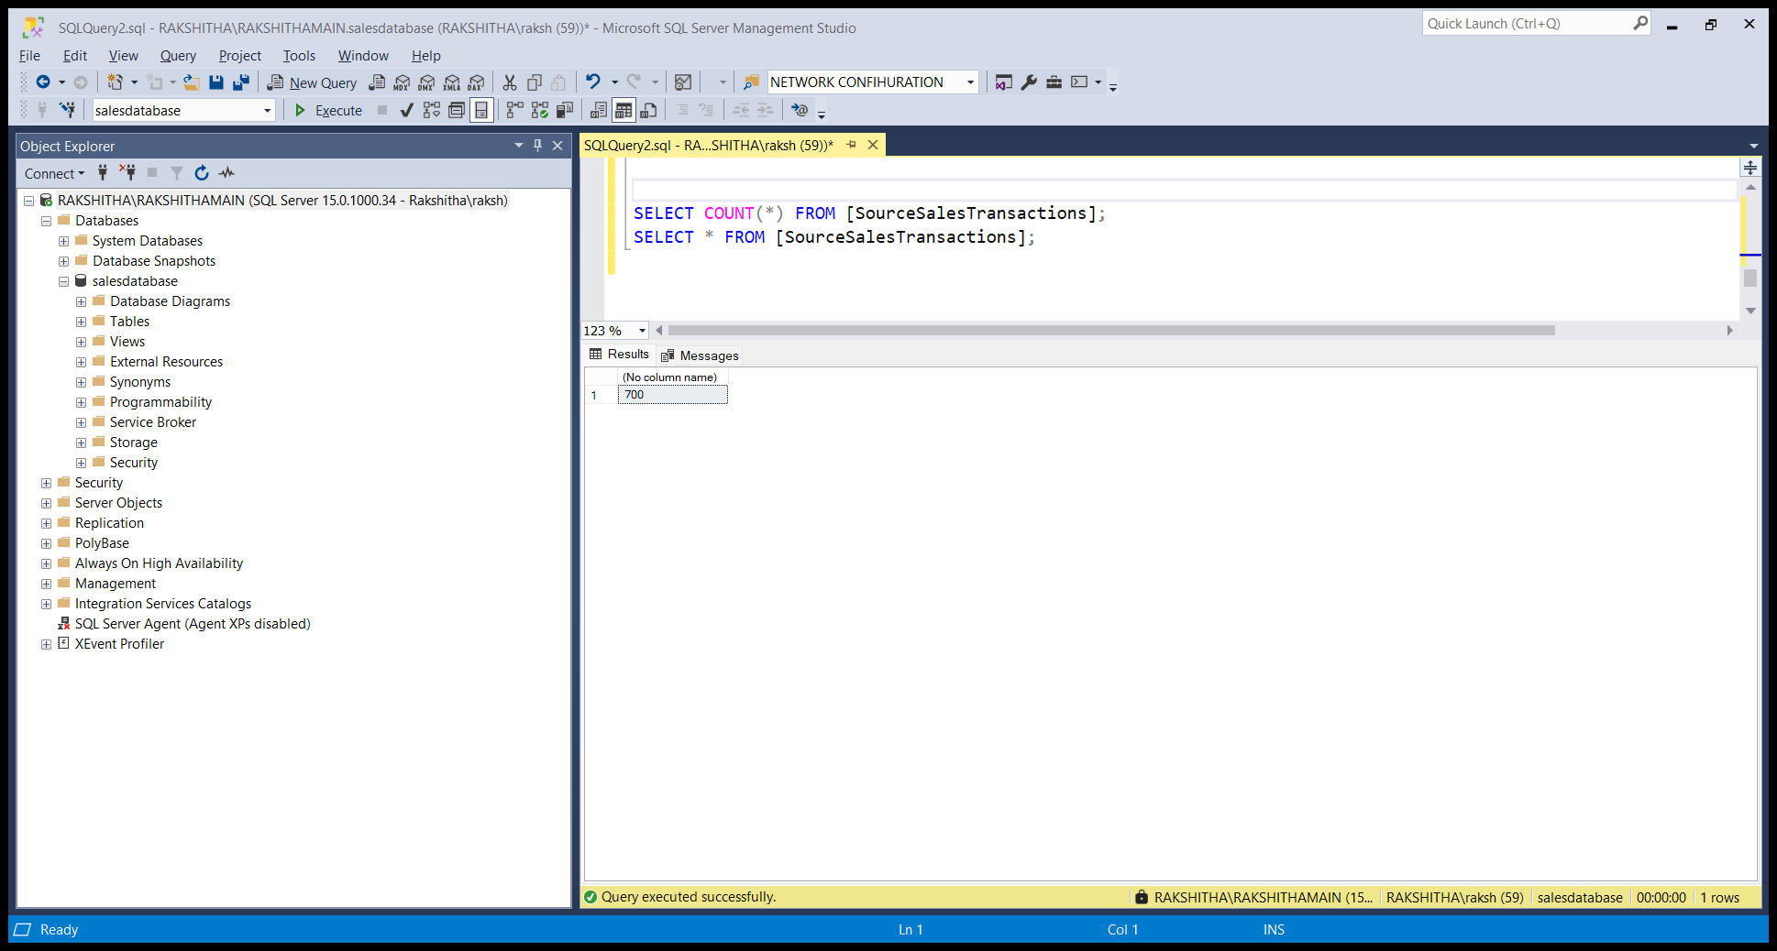

* **Inventory logs: Copy activity, source: Synapse Warehouse, sink: Azure SQL Database**

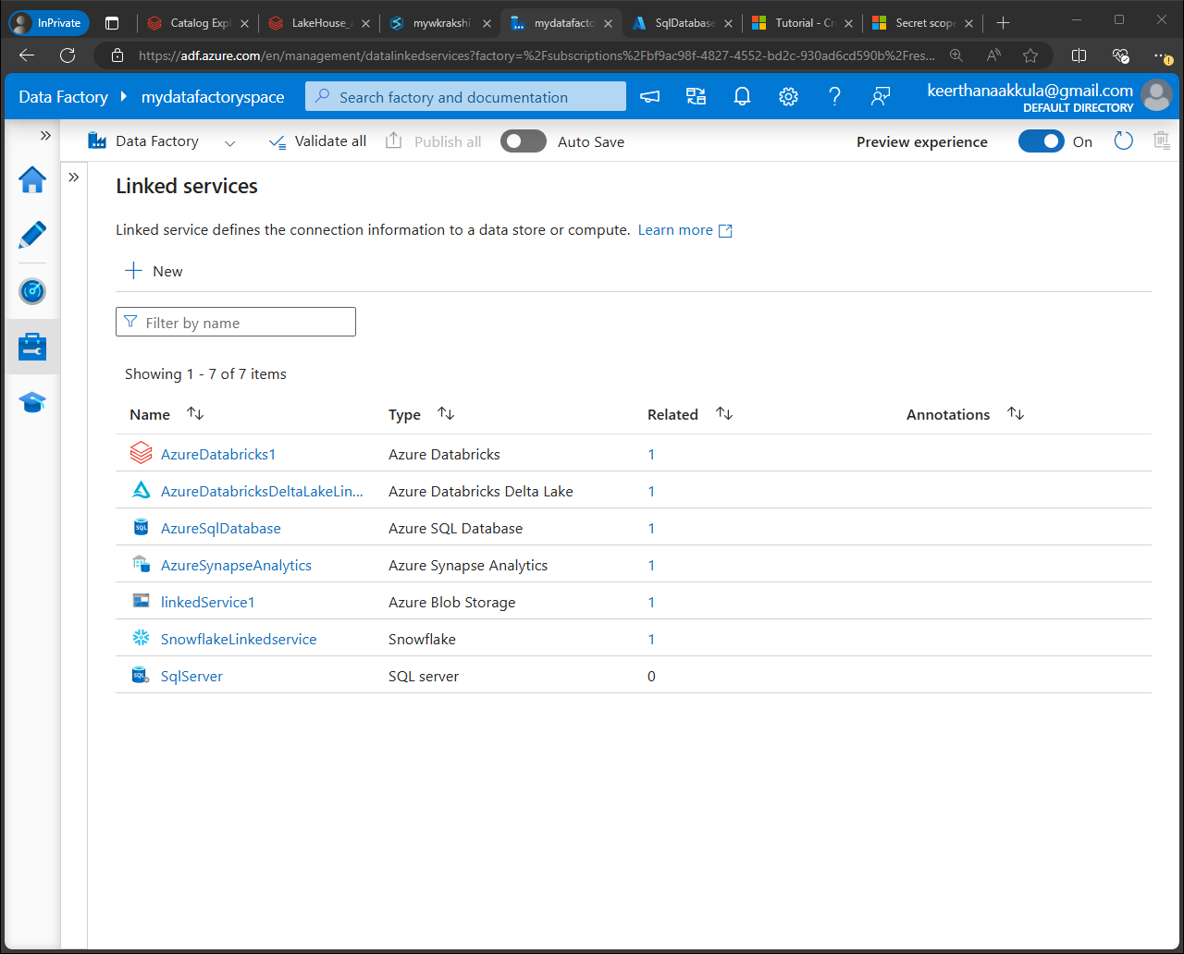

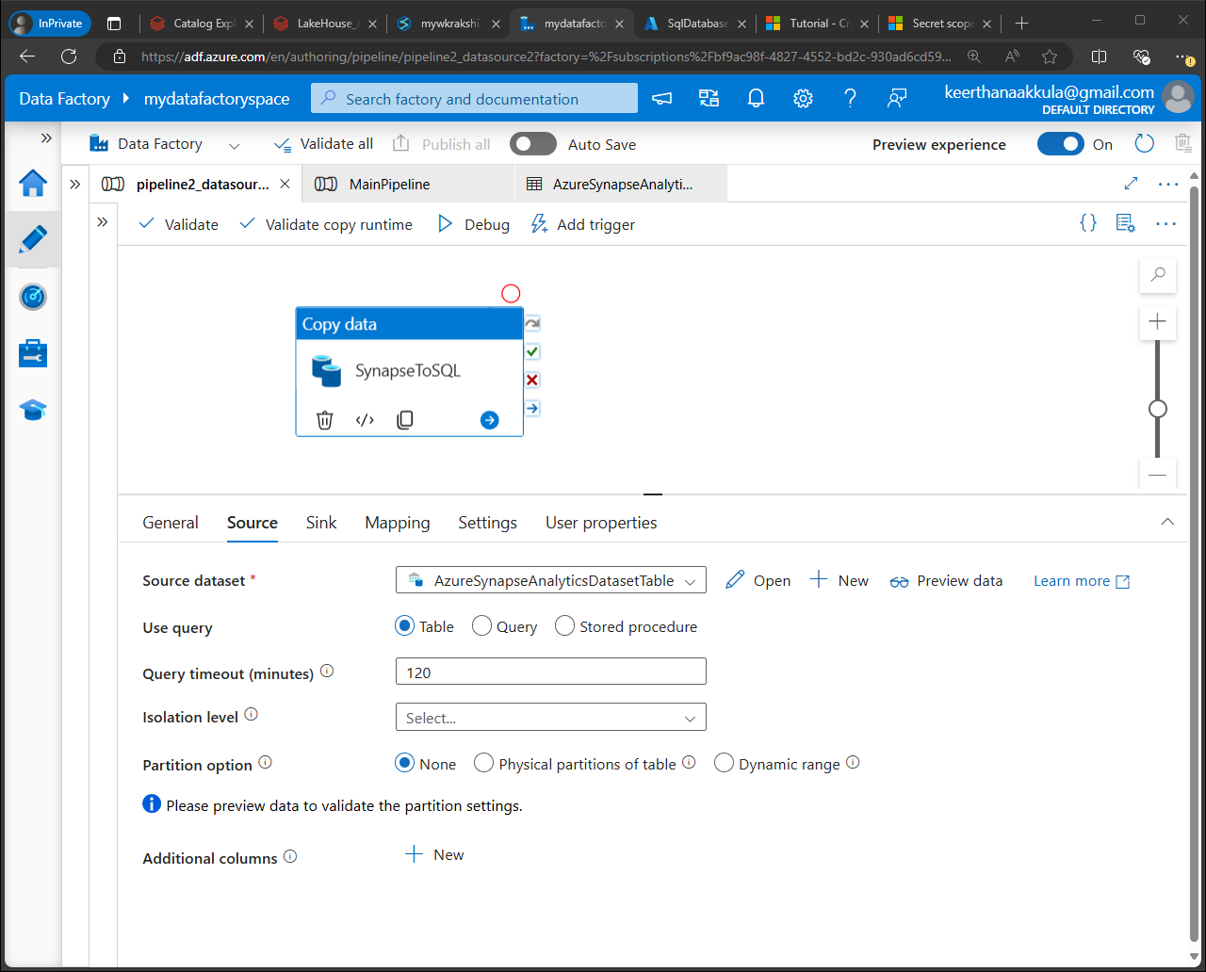

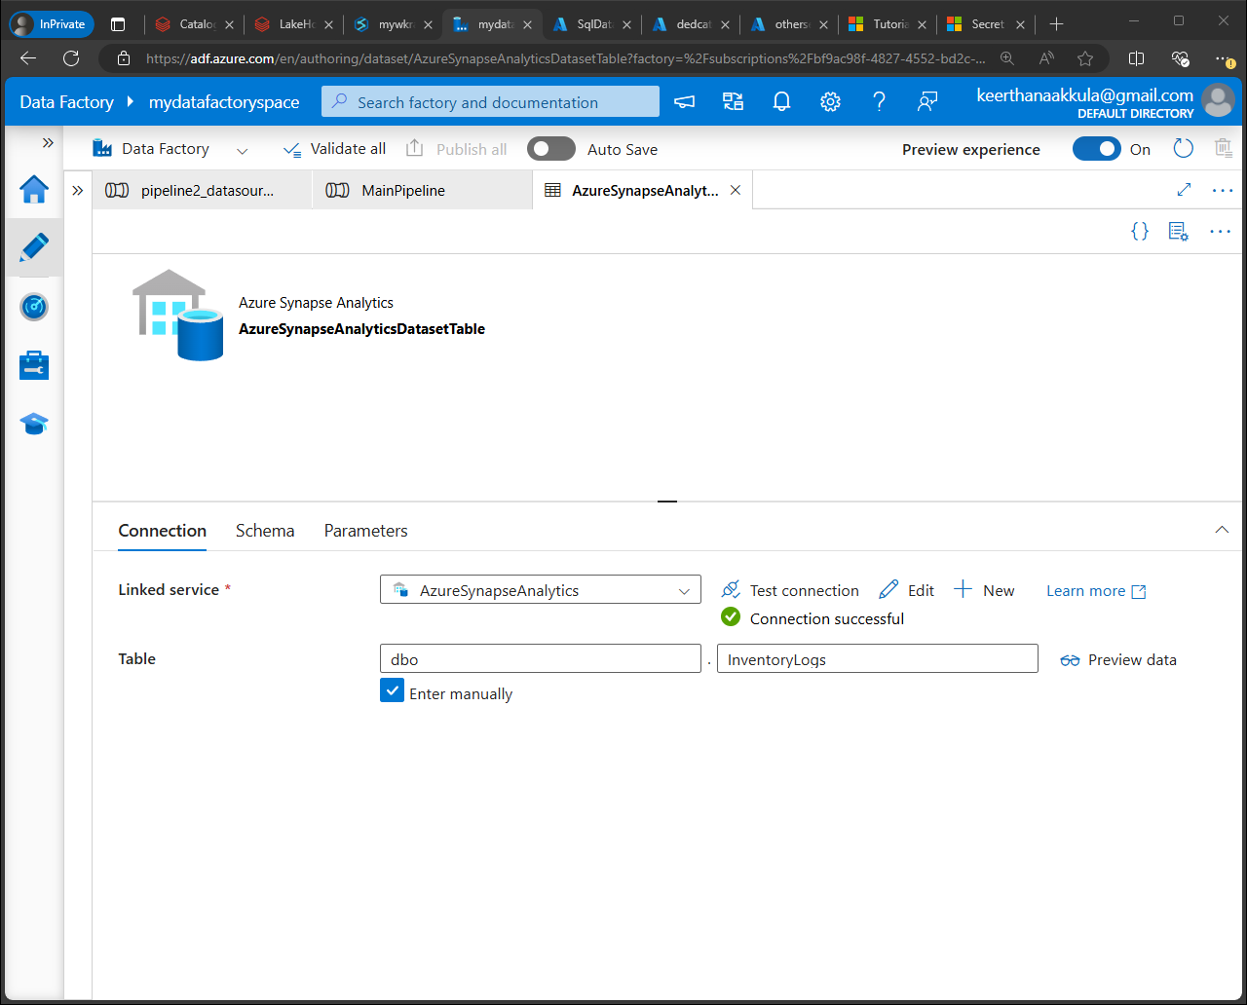

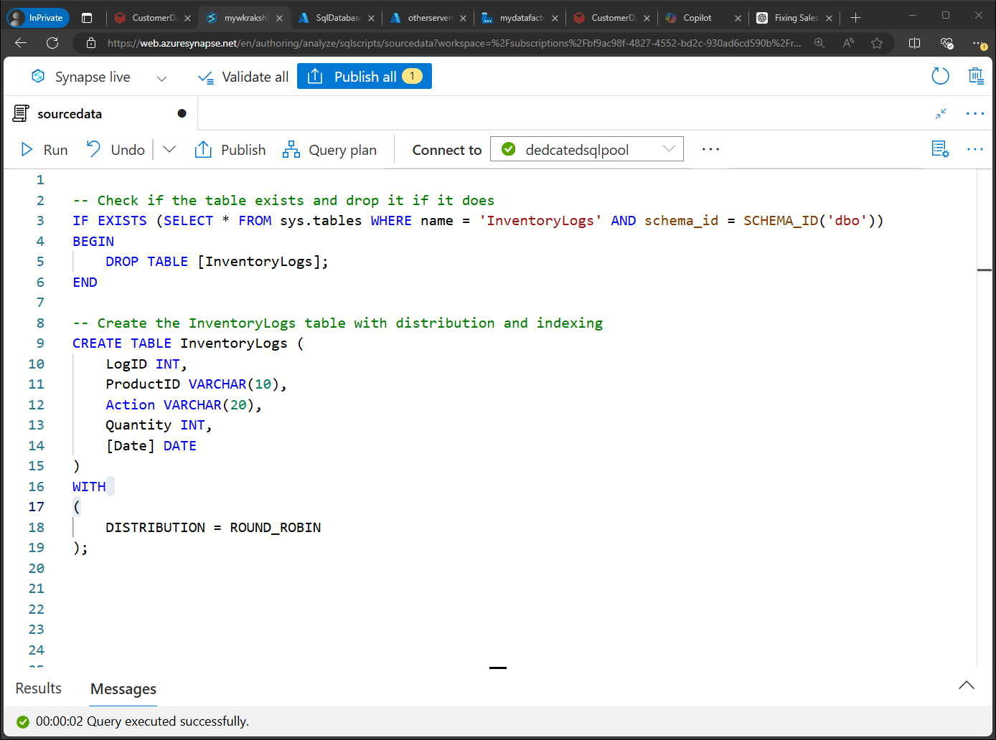

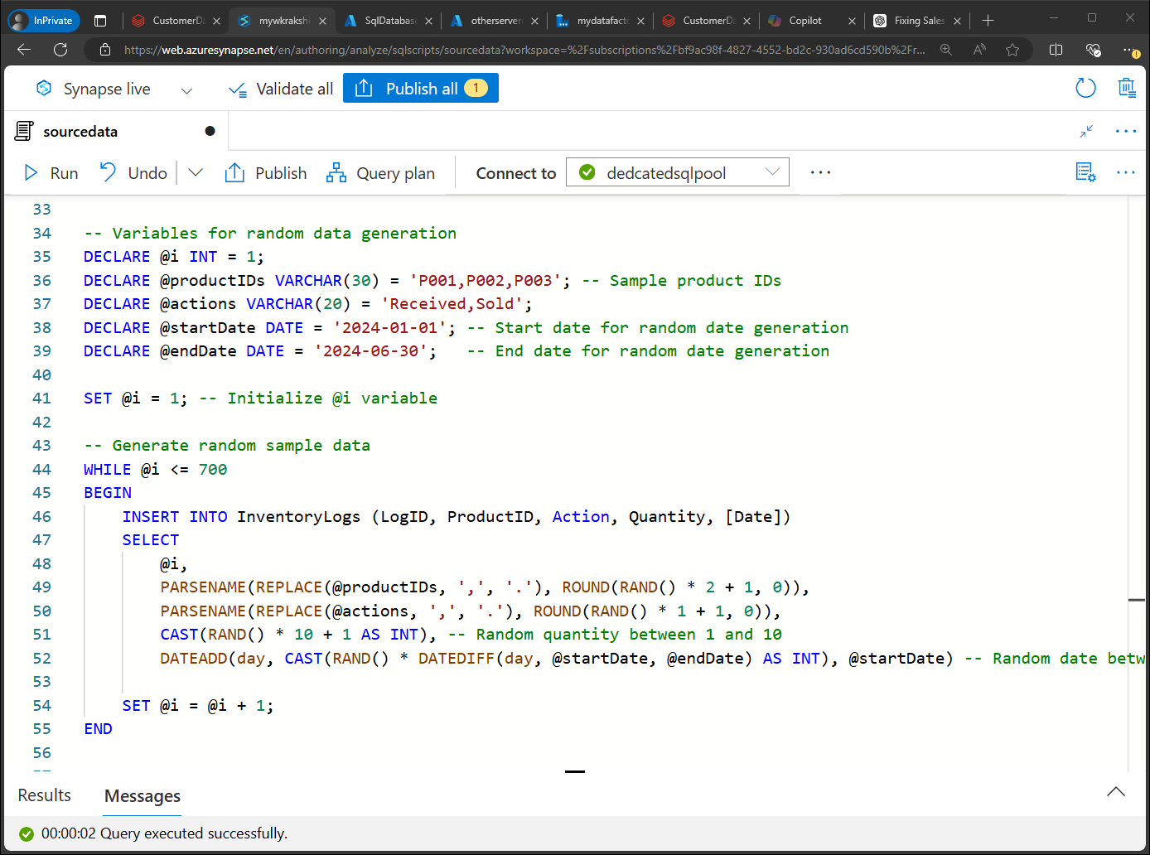

Used clustered column store index for speed up data retrieval and analysis tasks, especially for large datasets.

­­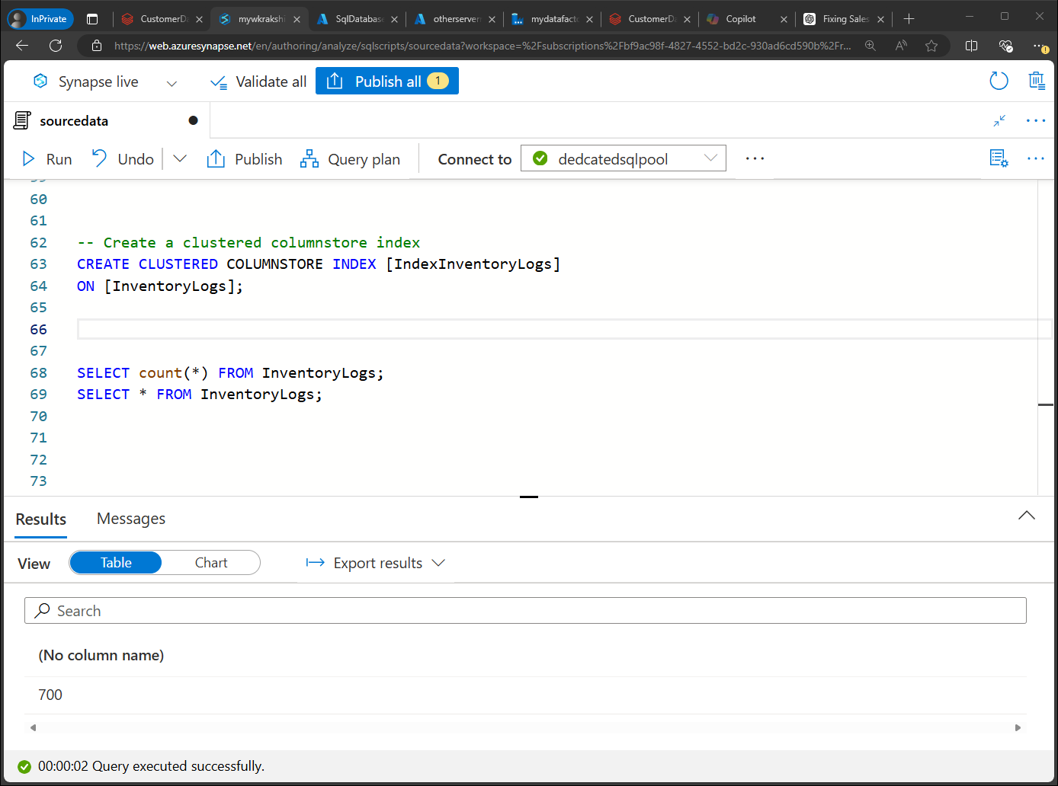

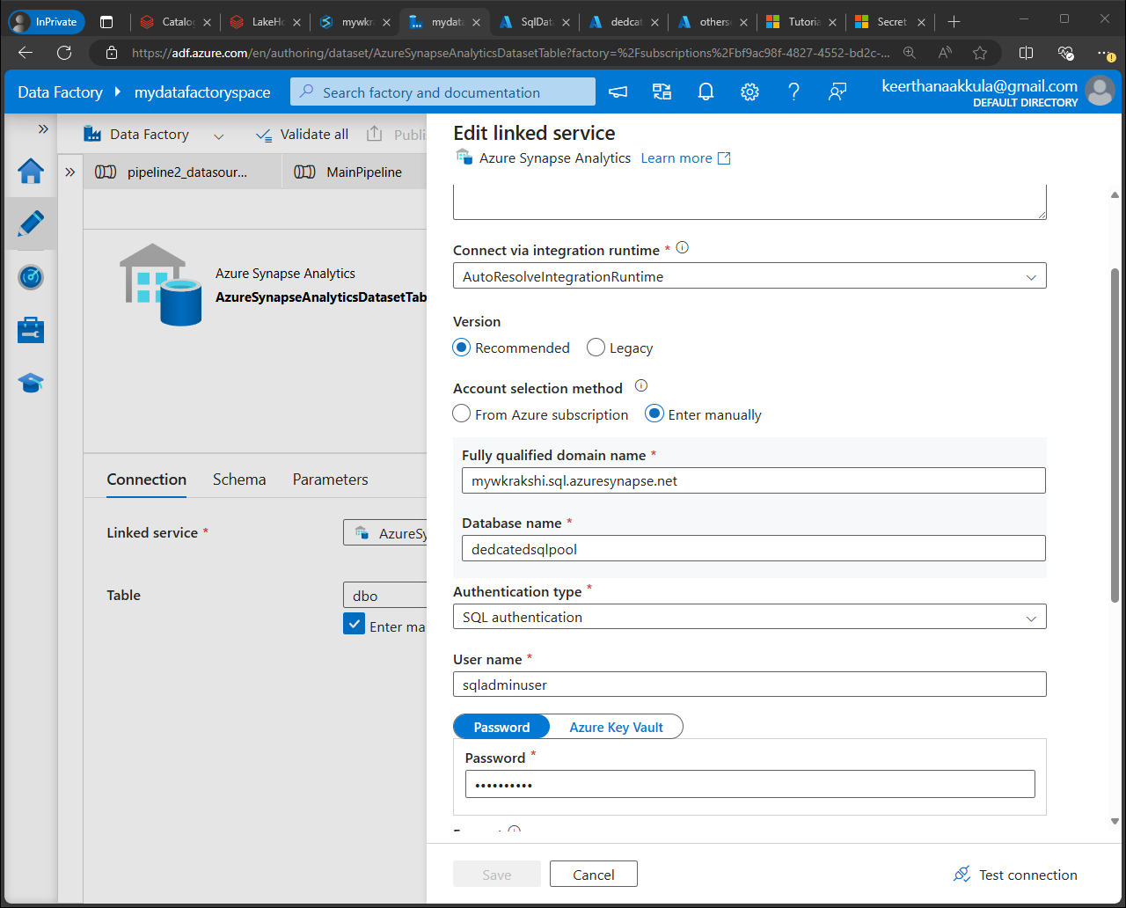

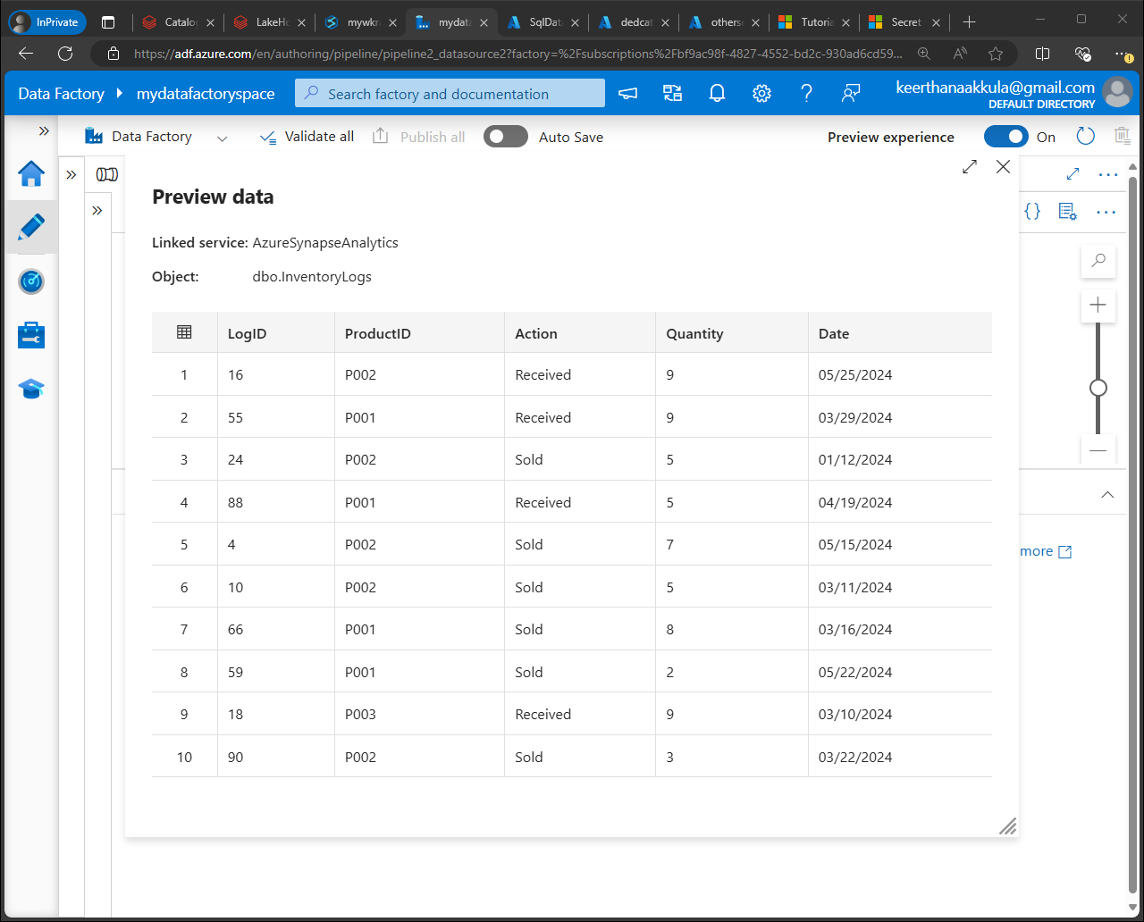

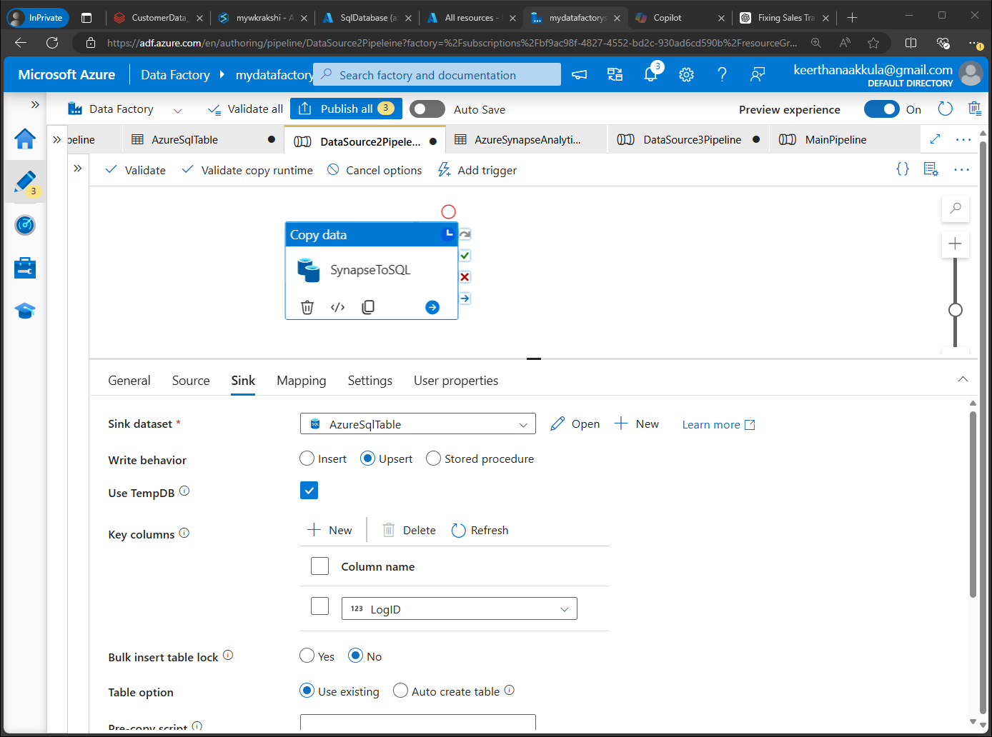

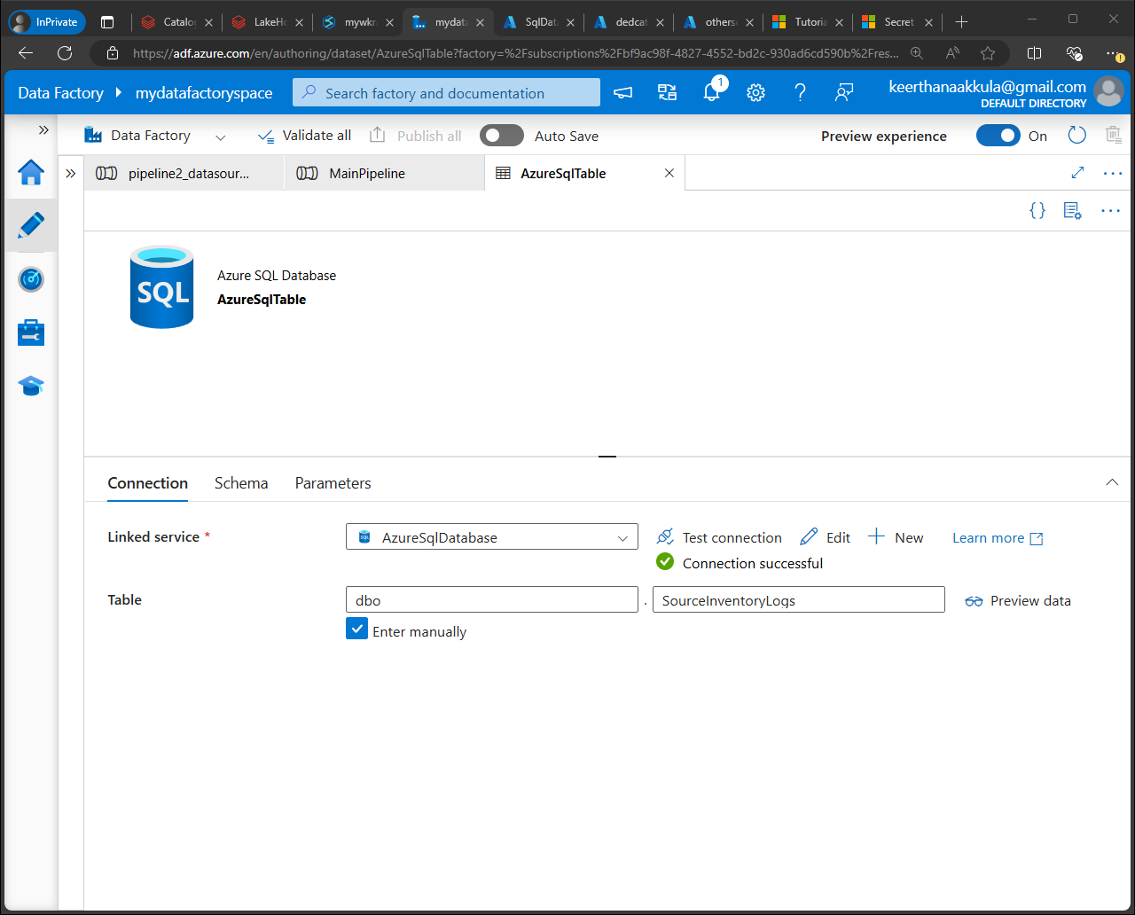

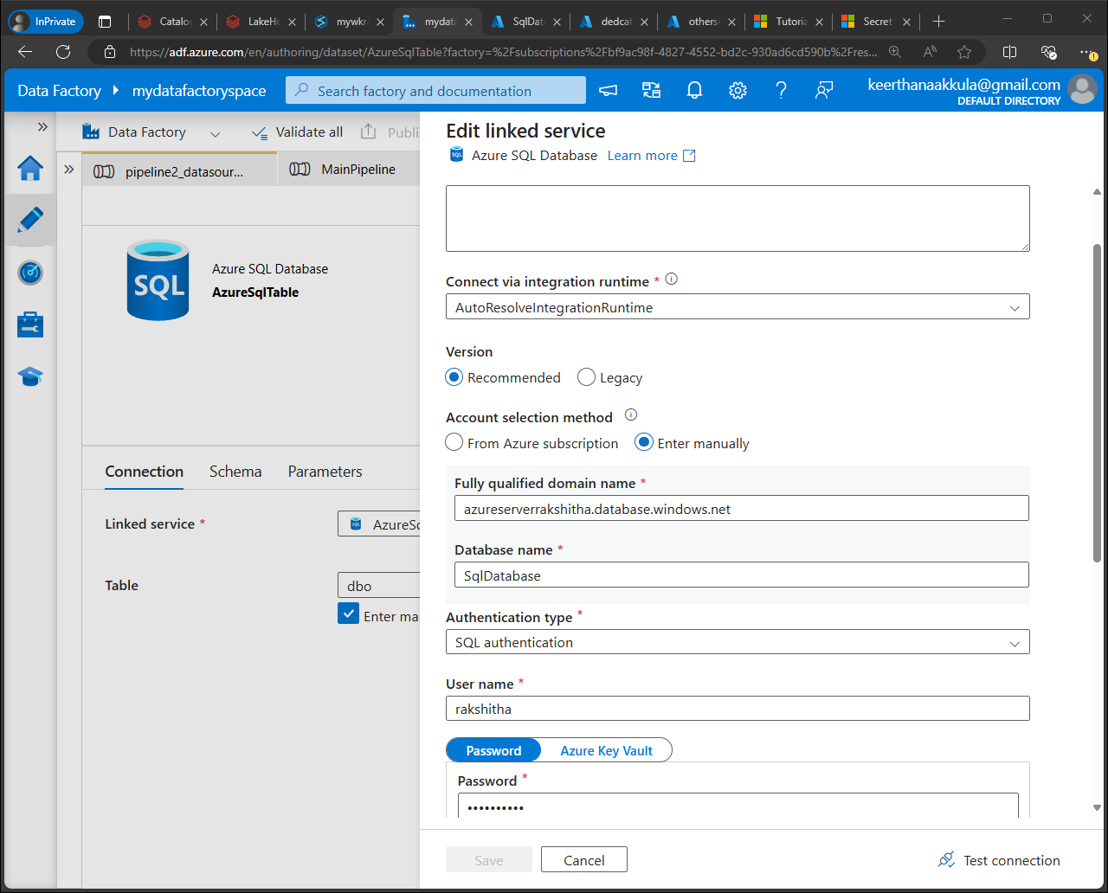

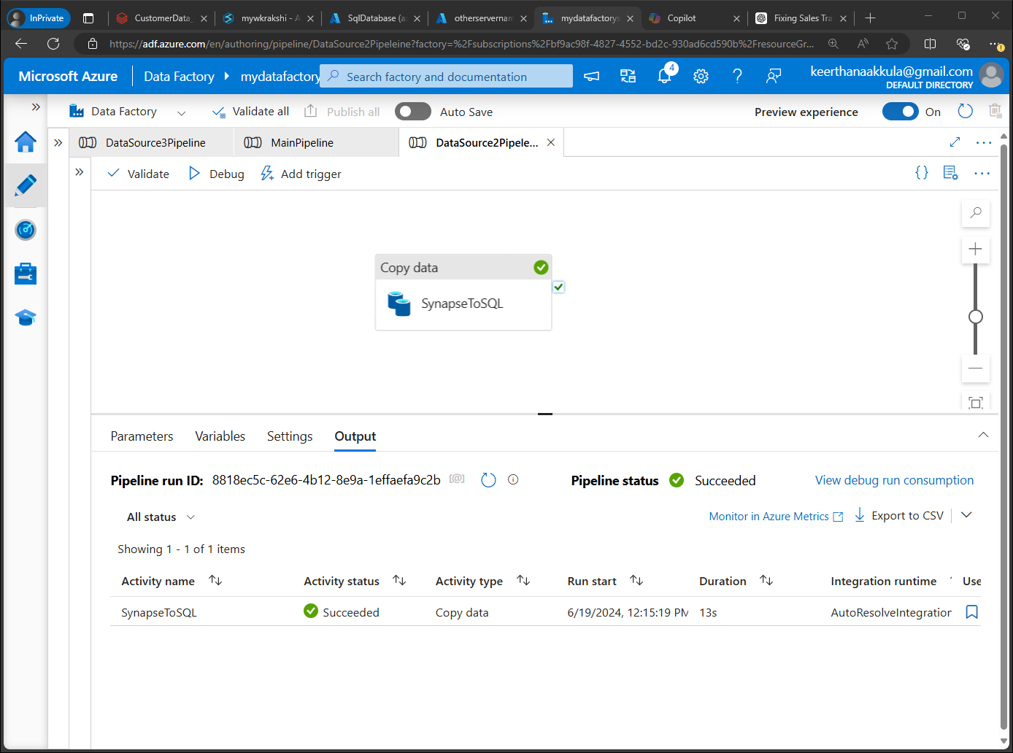

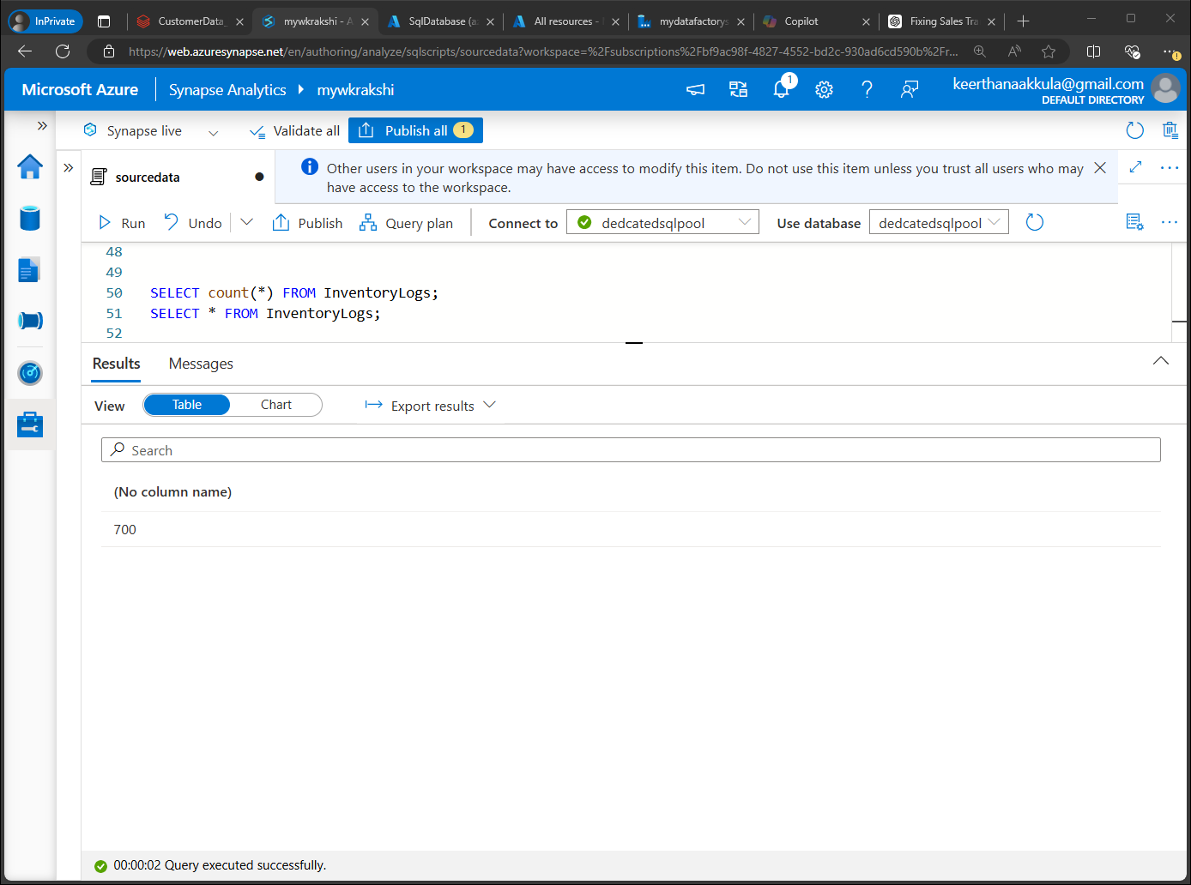

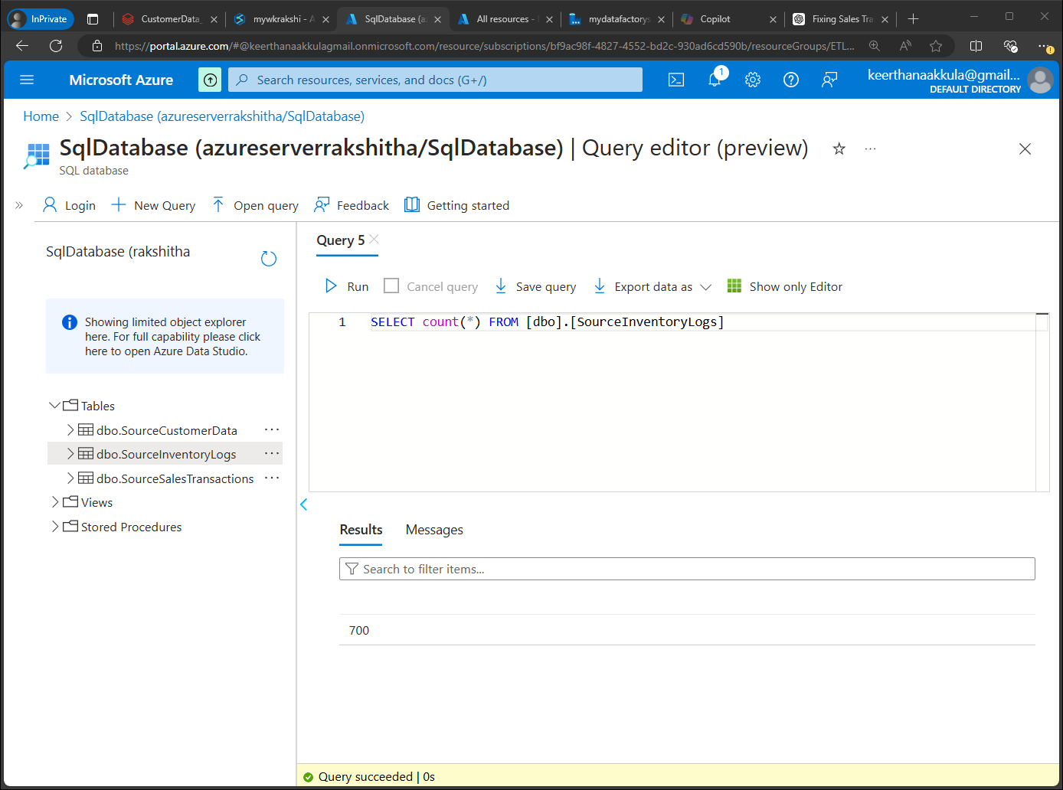

* **Customer data: Through Database connectors, Notebook Activity, Source: Azure database for MySQL (Azure data studio), sink: Azure SQL database**

 

We need to import the mysql connector jar file into databricks and connect to Azure database for MySQL via JDBC connections

To connect to an Azure Database for MySQL from Databricks using JDBC, you need to import the MySQL Connector/J jar file into your Databricks environment. This connector allows Databricks to interact with the MySQL database over JDBC (Java Database Connectivity)

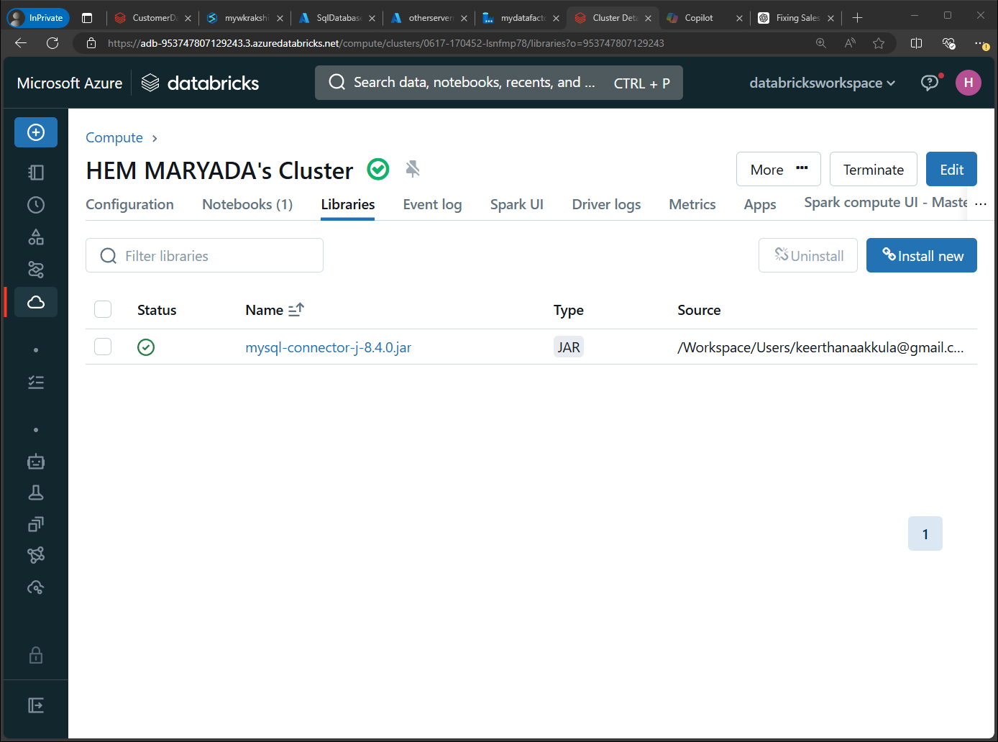

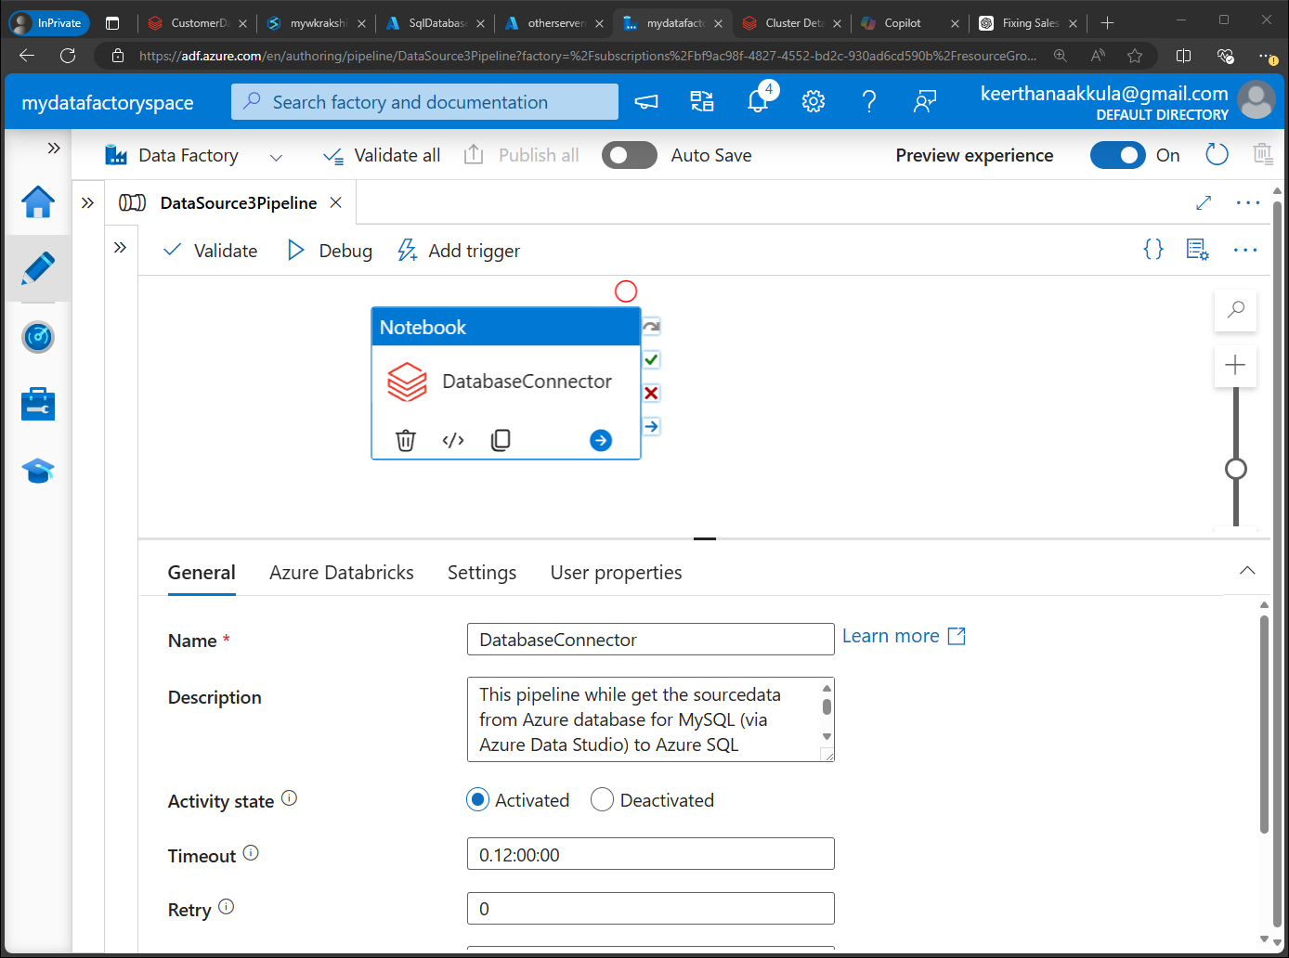

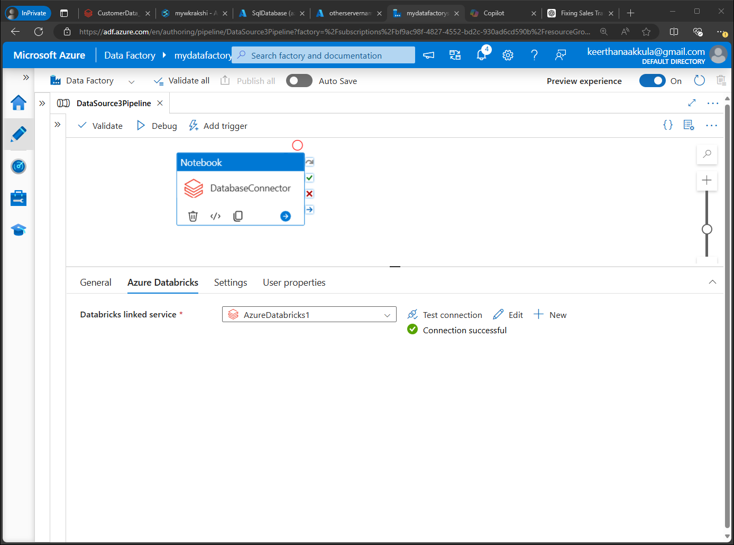

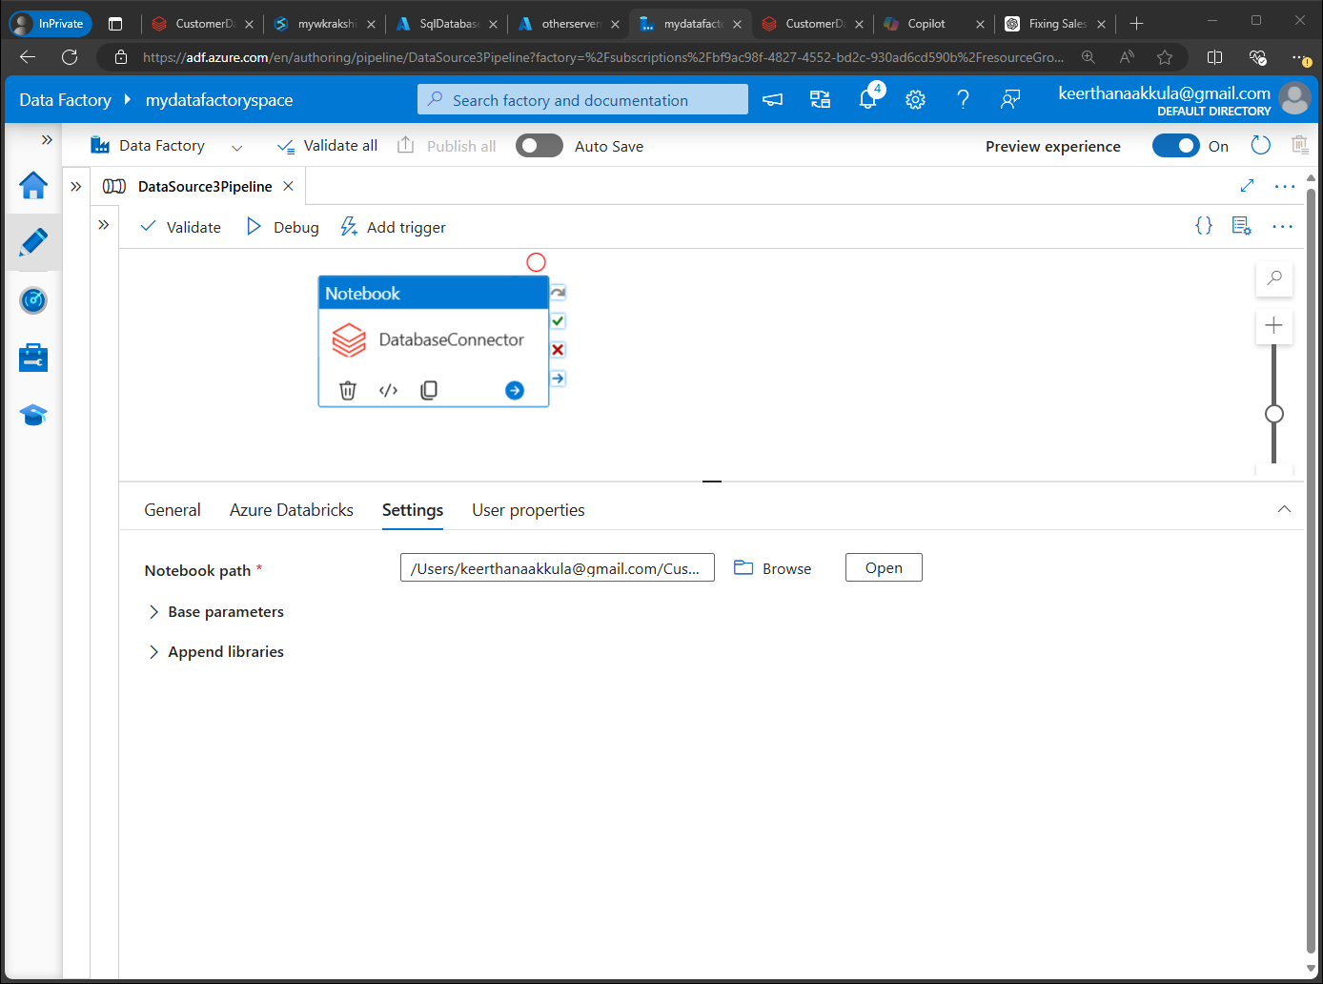

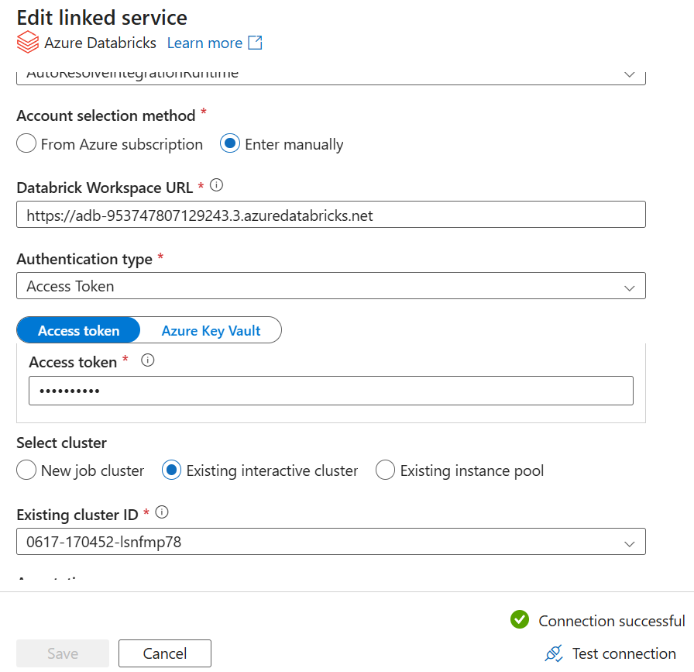

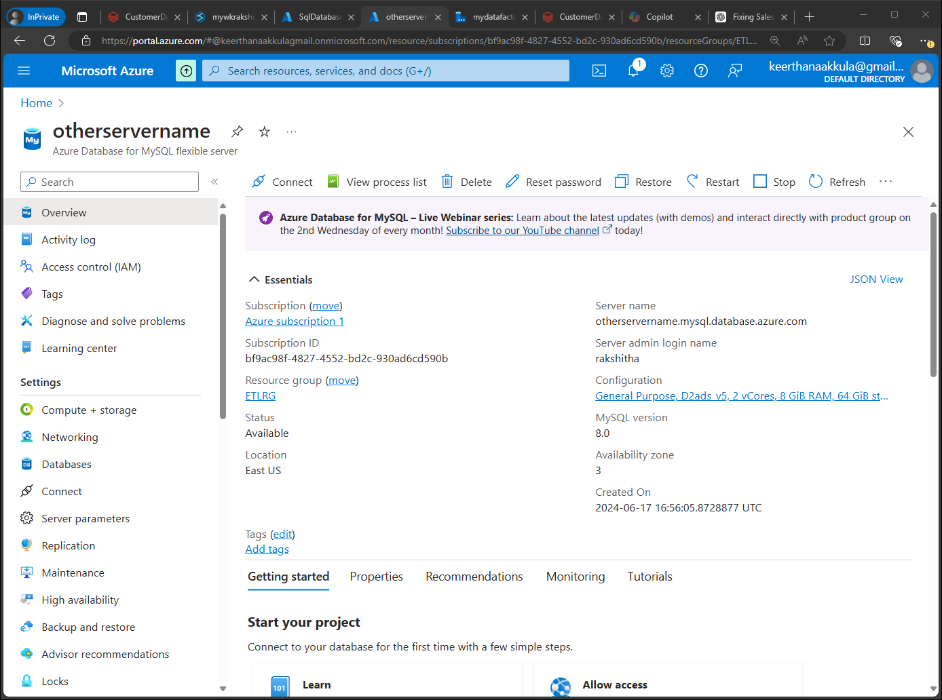

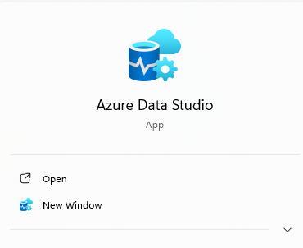

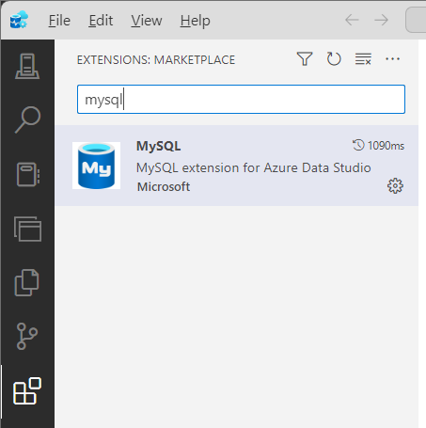

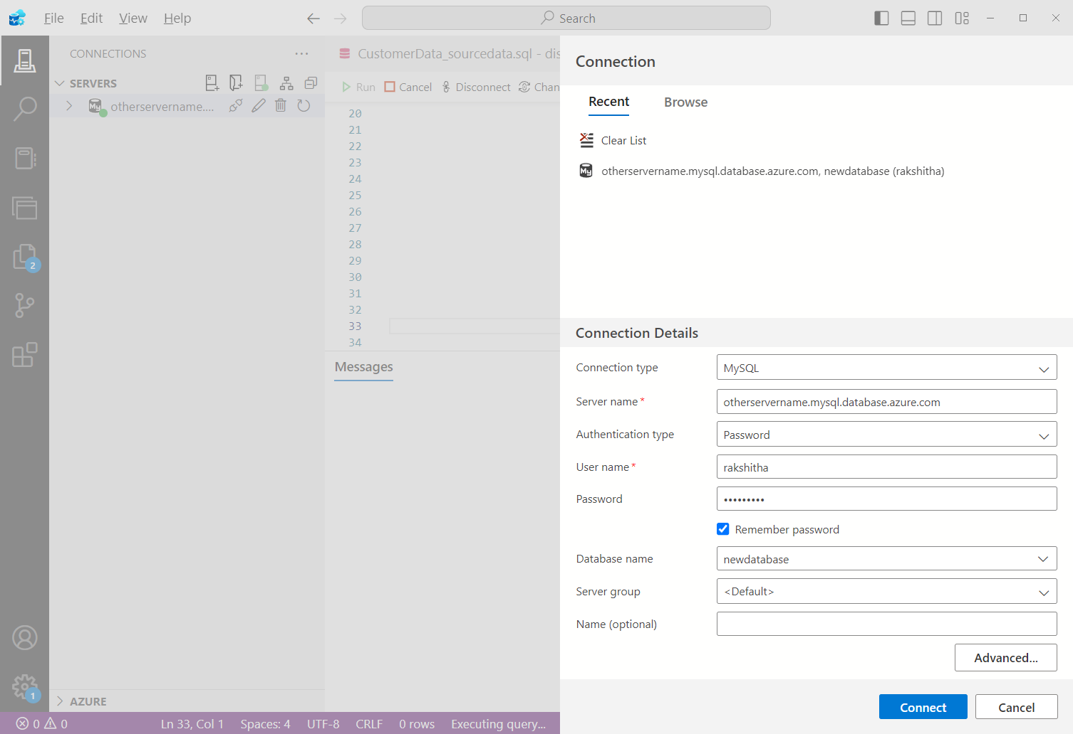

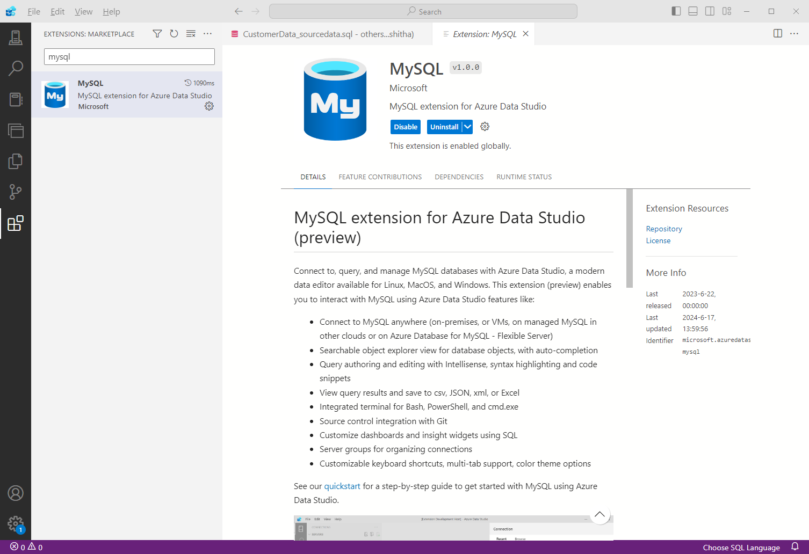

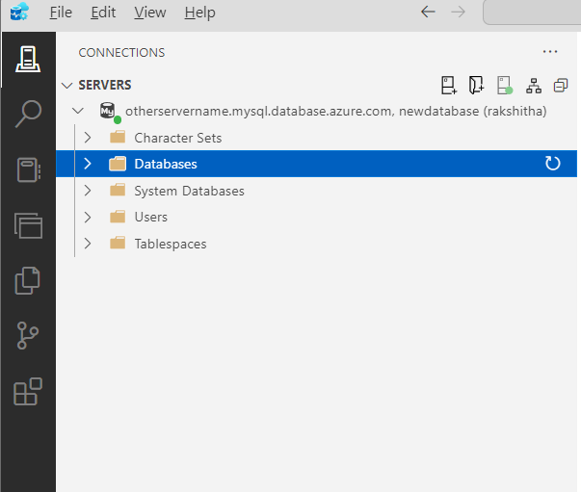

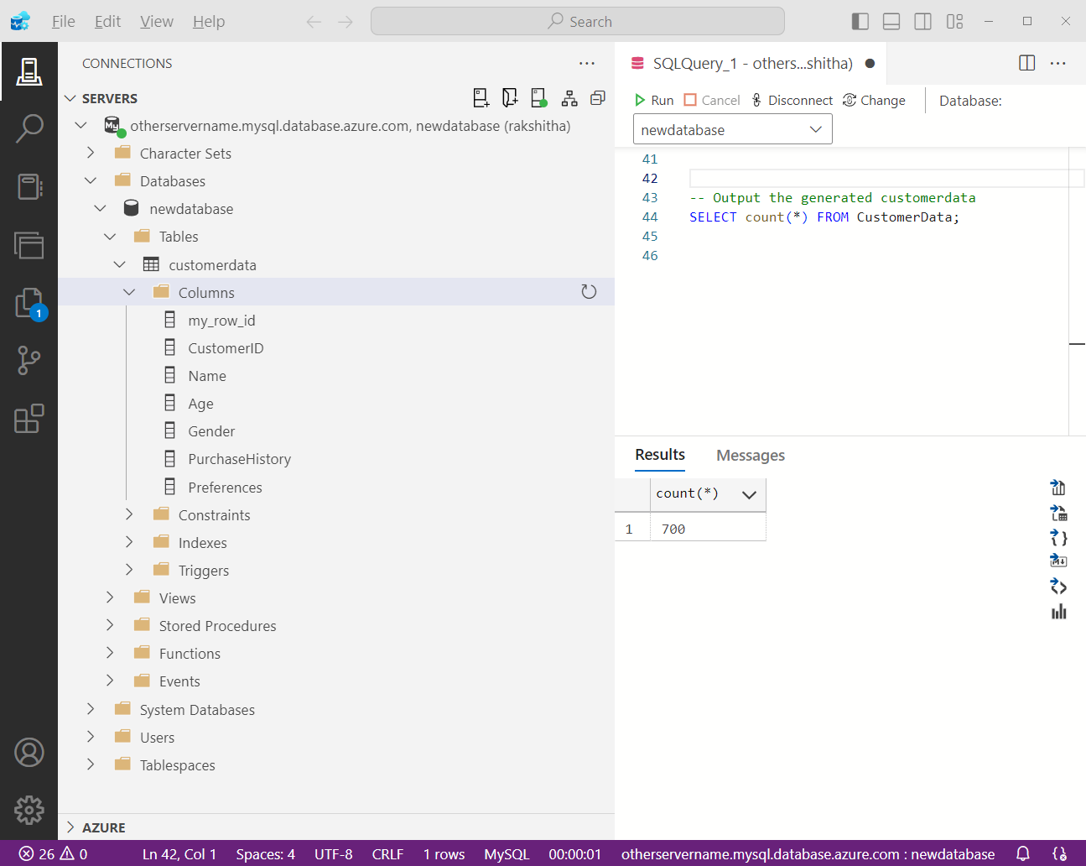

Created a random customer data in Azure Database for MySQL flexible server via Azure data studio

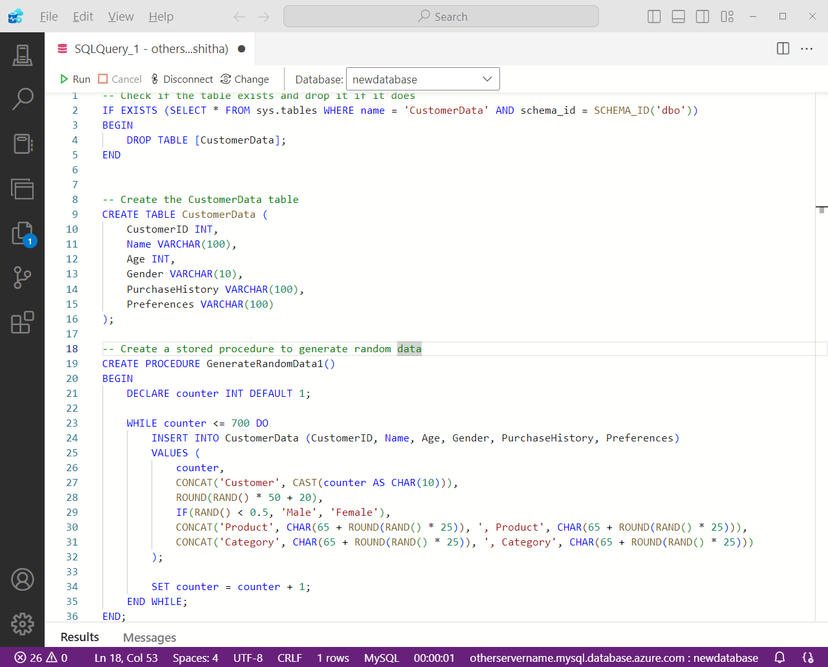



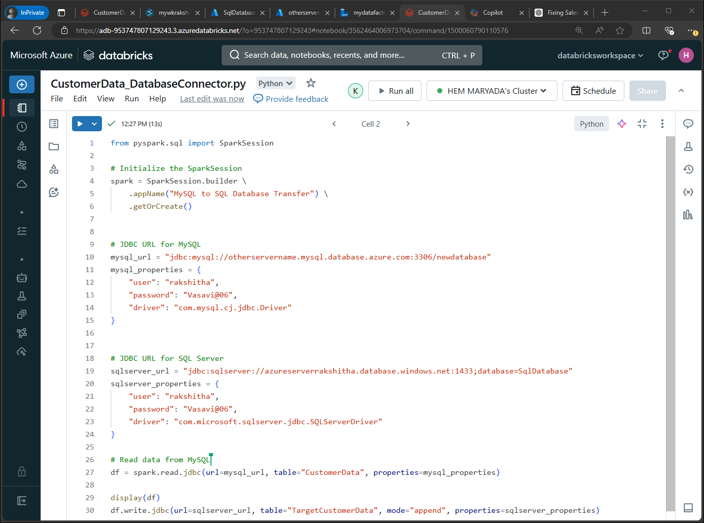

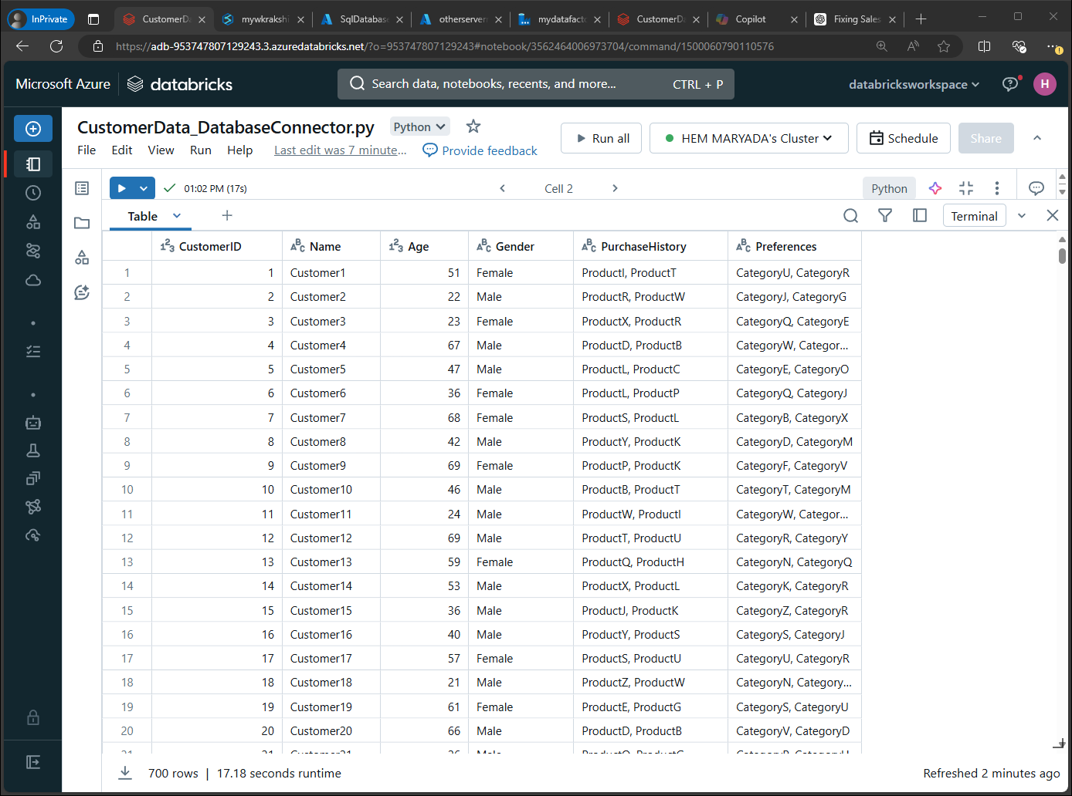

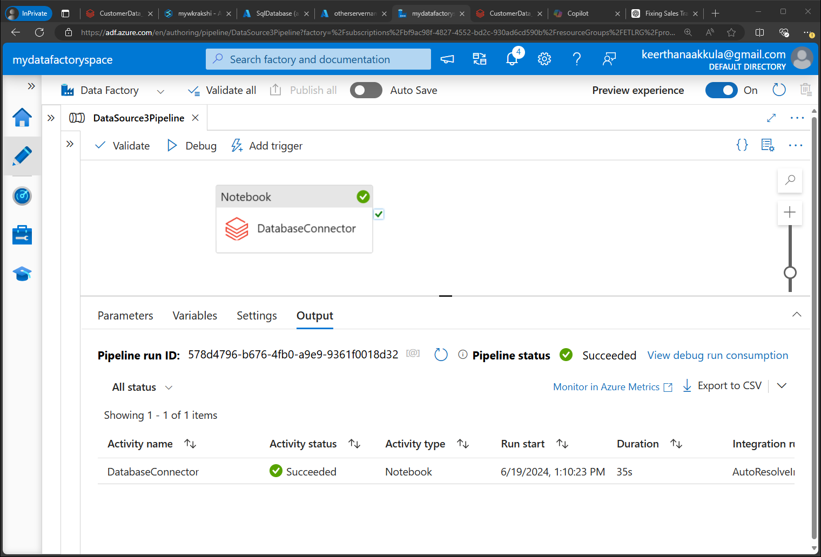

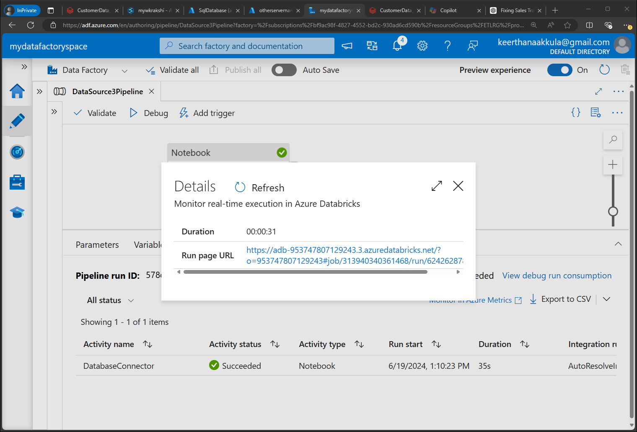

1. **Data Storage: Now all the data sources are stored in Azure SQL Database:** Now all the 3 data sources are in Azure SQL Database, I have created a pipeline to copy the data from Azure SQL Database to Snowflake
2. **Data Transformation: Pyspark (notebook):** Created a notebook that implements the **Lakehouse Architecture** (medallion)
3. **Data Warehousing and Analytics:** **Snowflake, Power BI**, I have created a pipeline to copy the data from Azure SQL Database to Snowflake

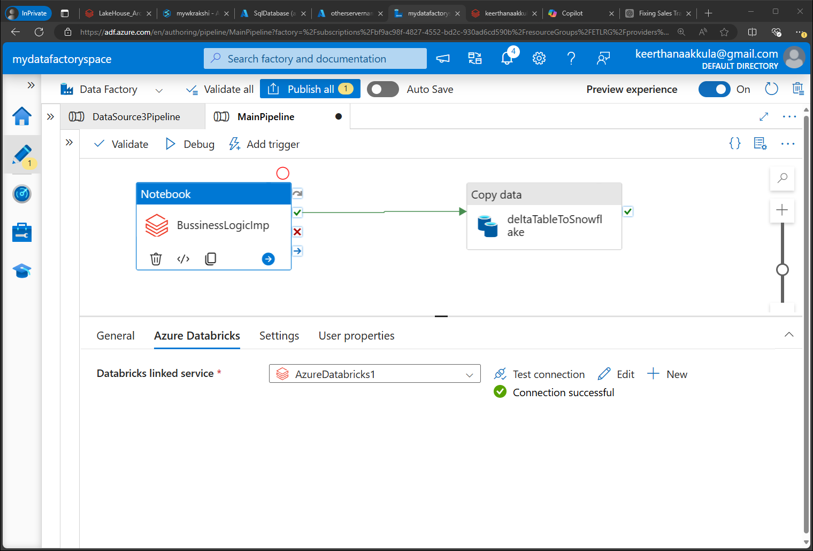

The Medallion Architecture, also known as the Lakehouse Architecture, is a data management pattern that organizes data in layers to improve data quality, processing efficiency, and maintainability. This architecture typically involves three layers:

1. **Bronze (Raw Data) Layer**: Stores raw data in its original format.
2. **Silver (Refined Data) Layer**: Contains cleaned and processed data, ready for analytics.
3. **Gold (Serving) Layer**: Consists of highly refined data used for reporting and dashboards.

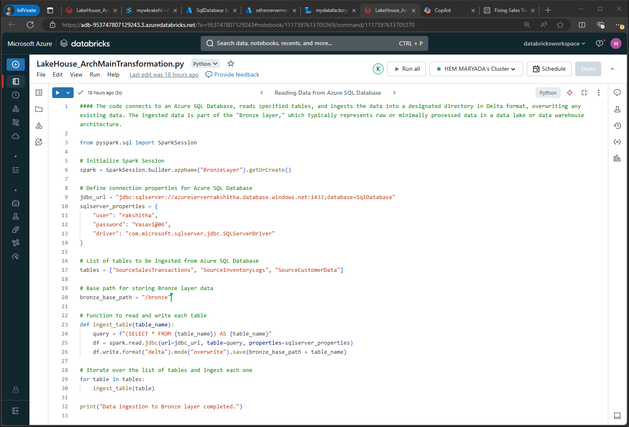

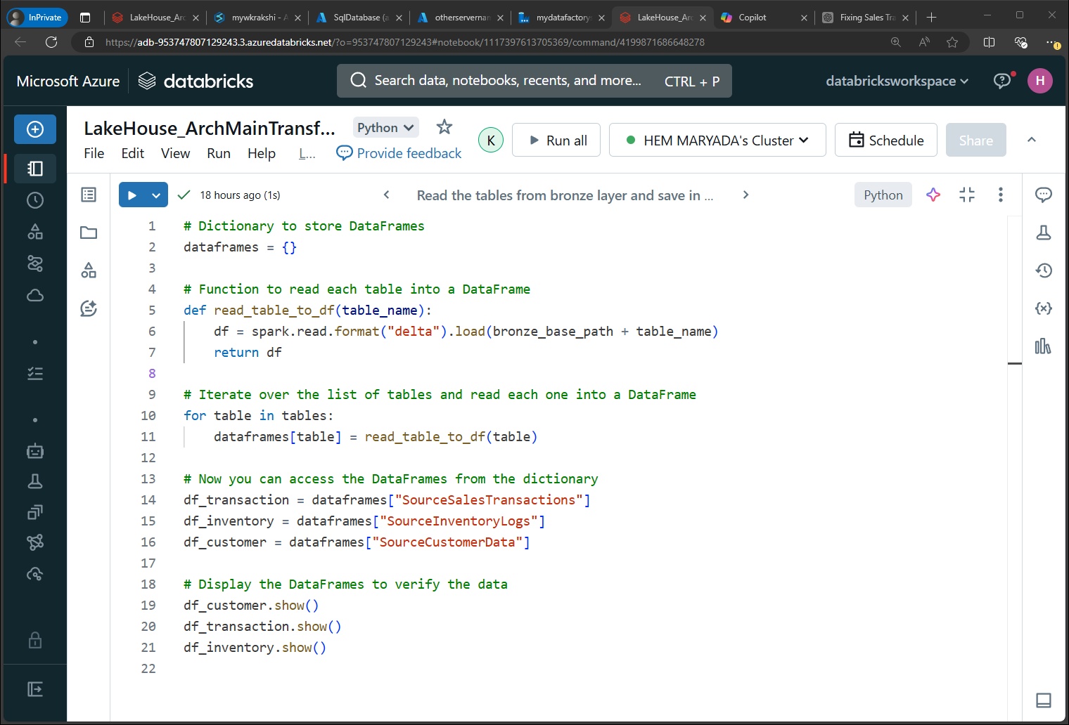

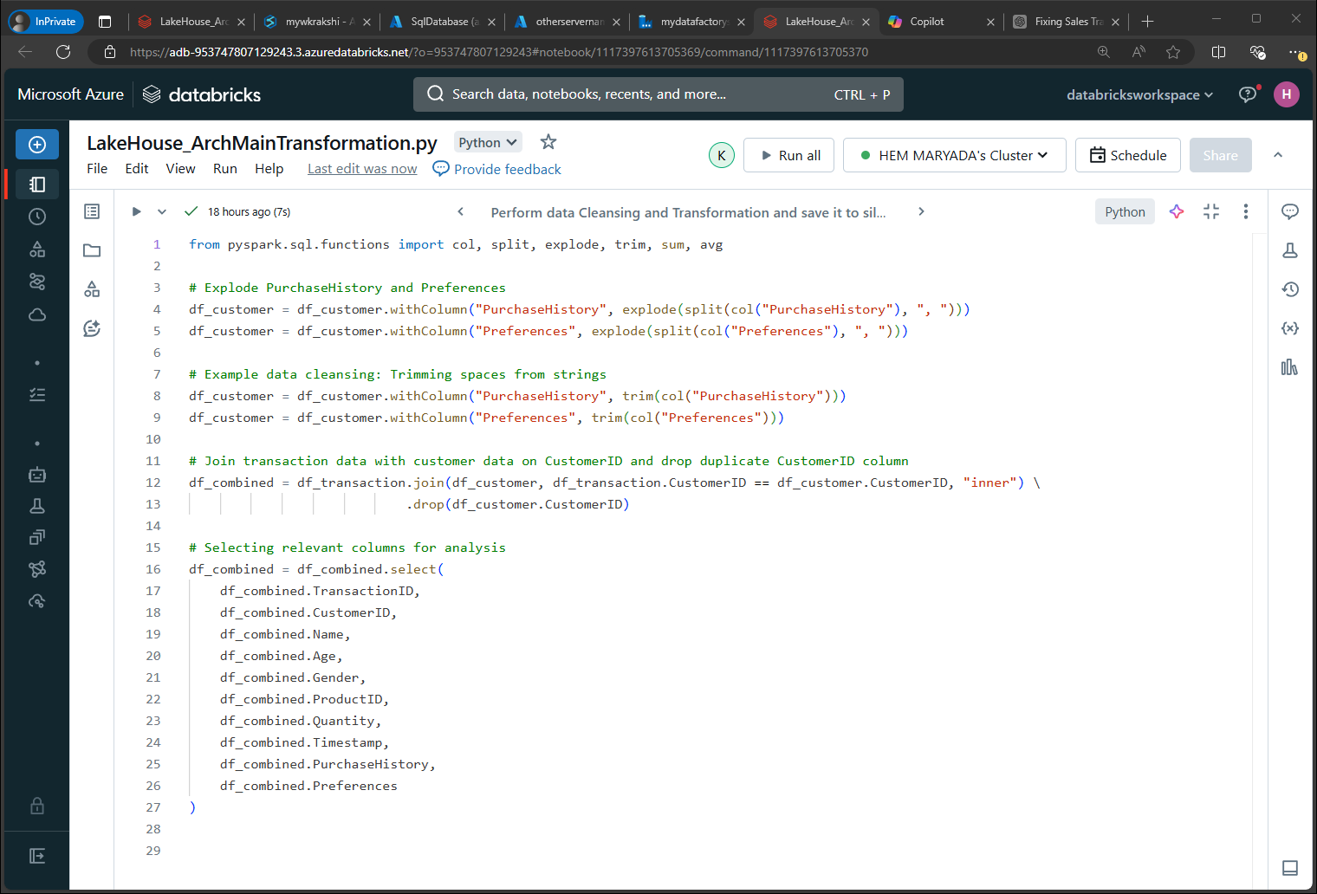

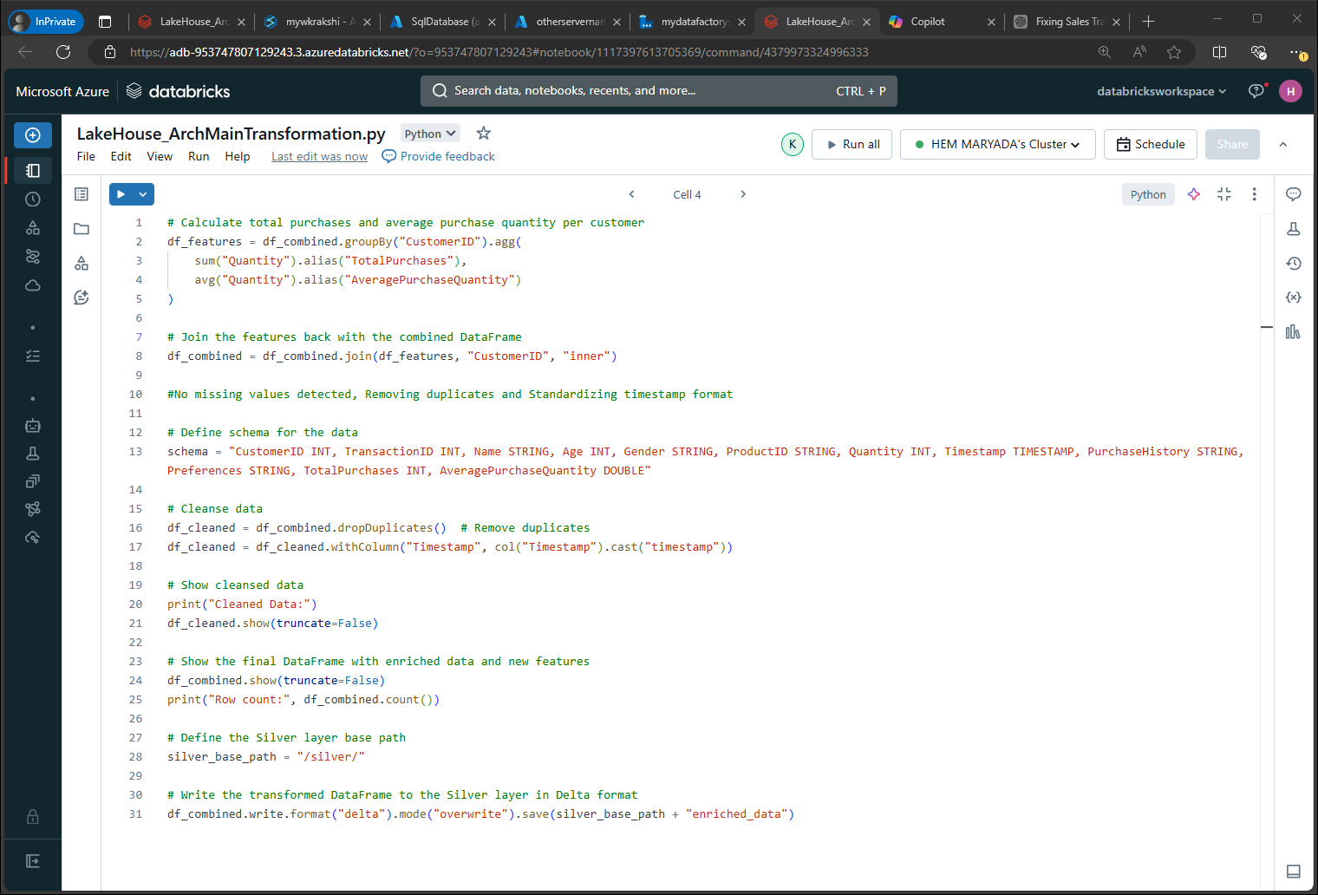

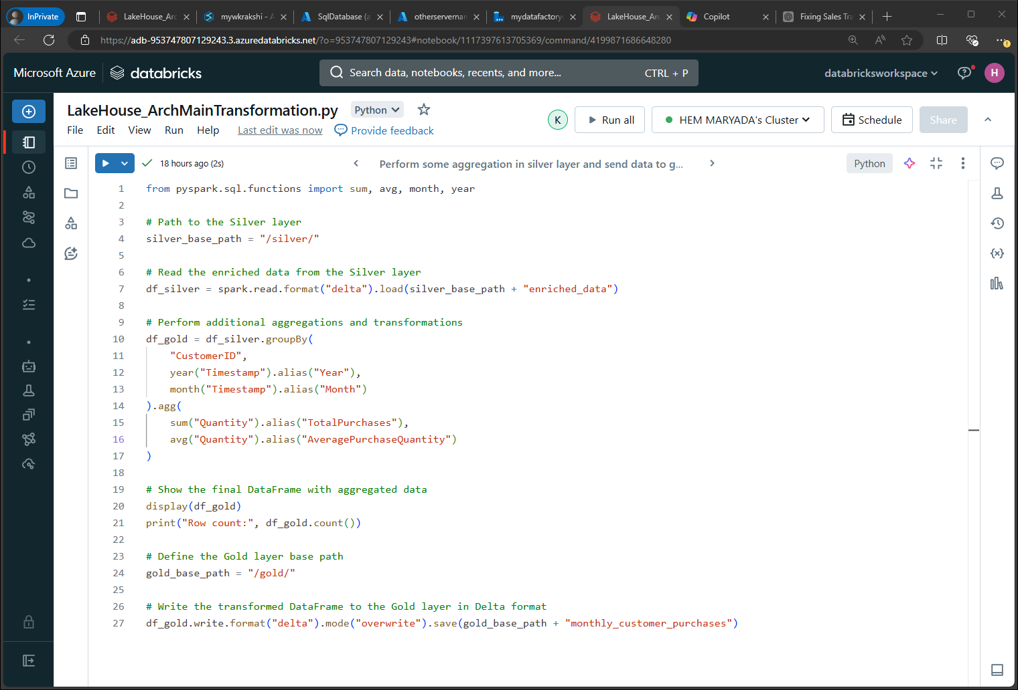

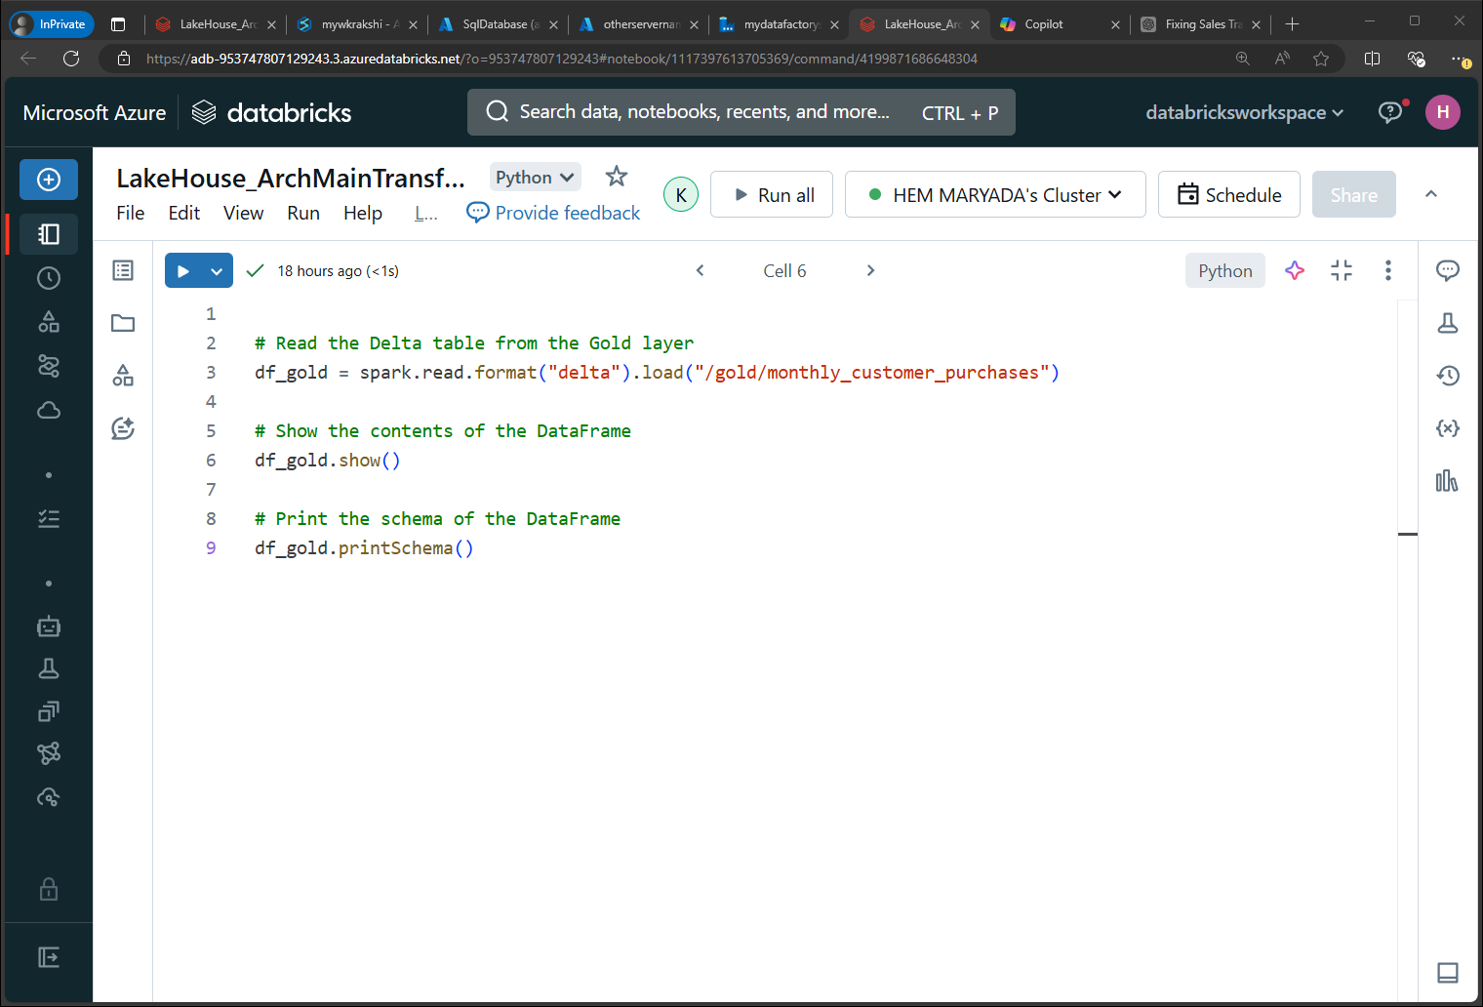

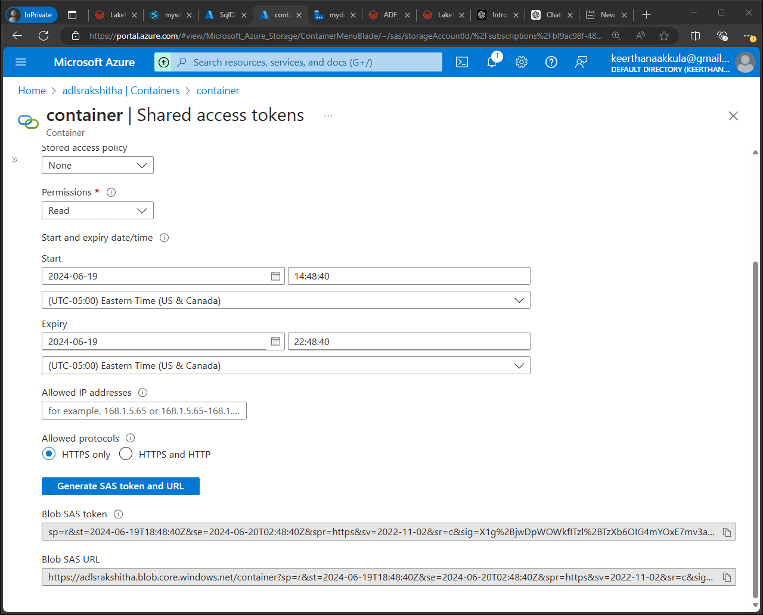

Keep the Blob SAS URL in the SAS URL and leave the SAS token blank in data factory as shown below

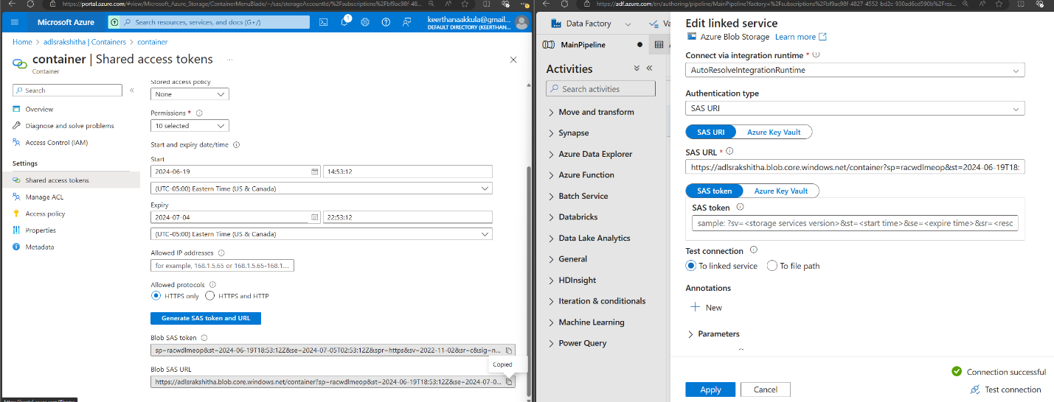

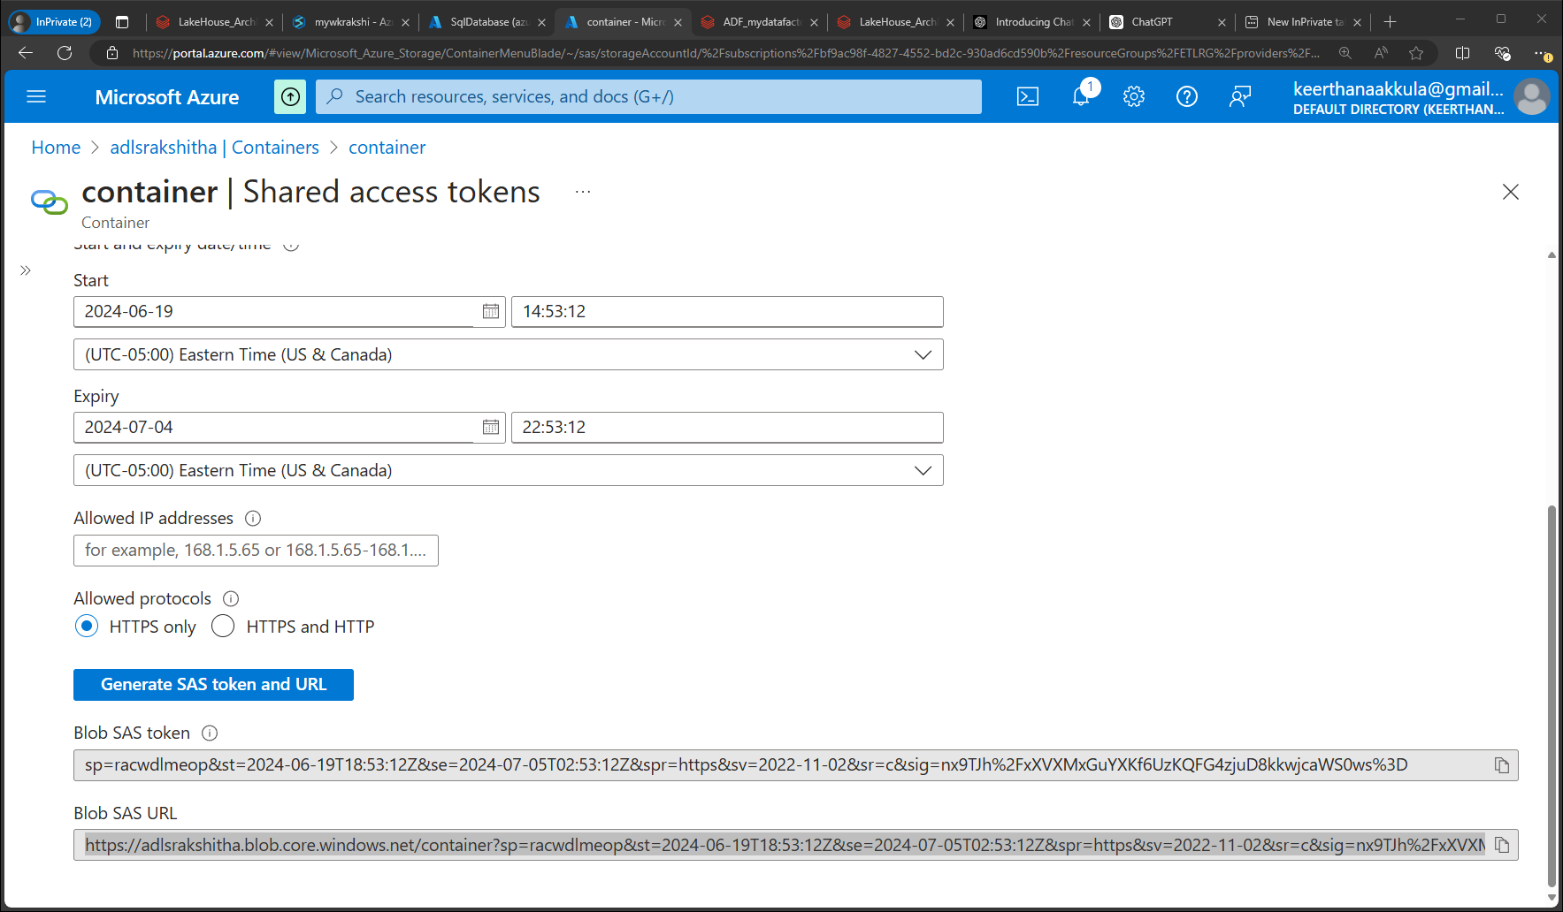

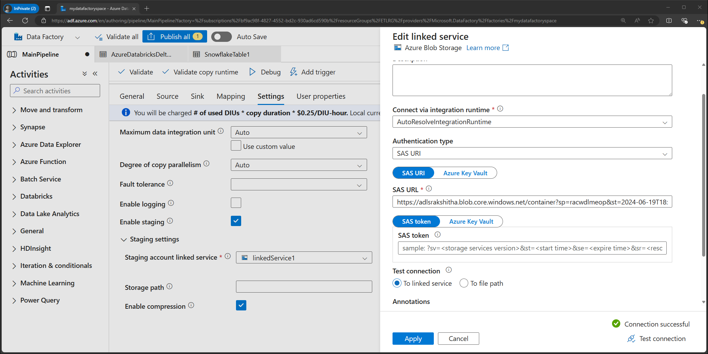

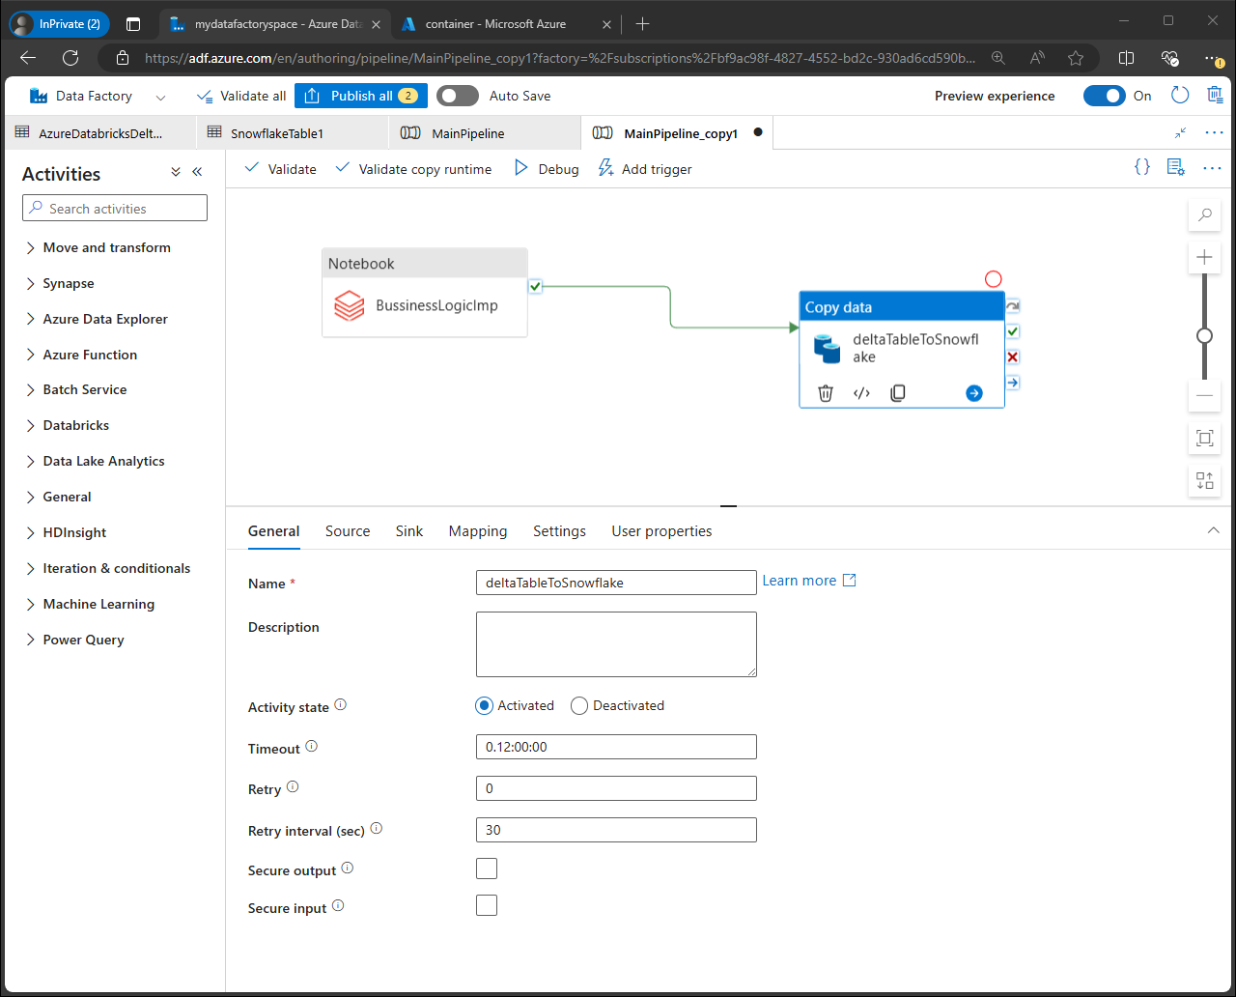

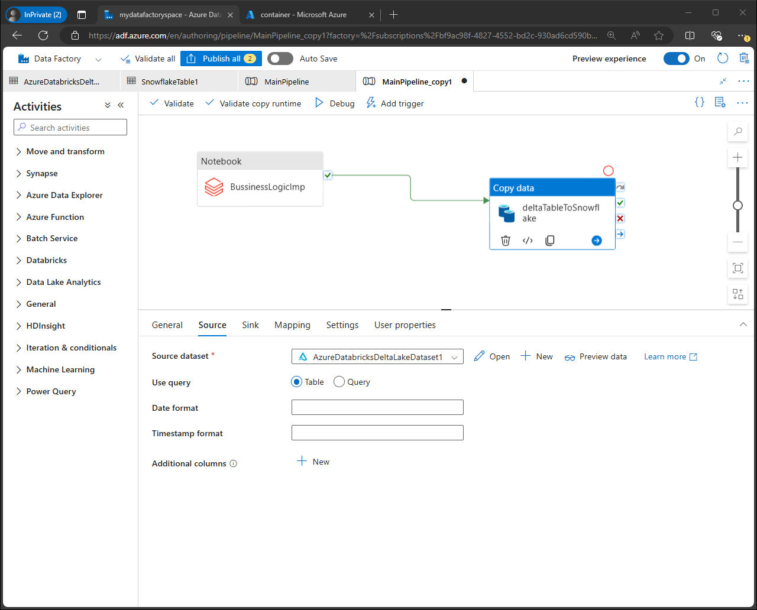

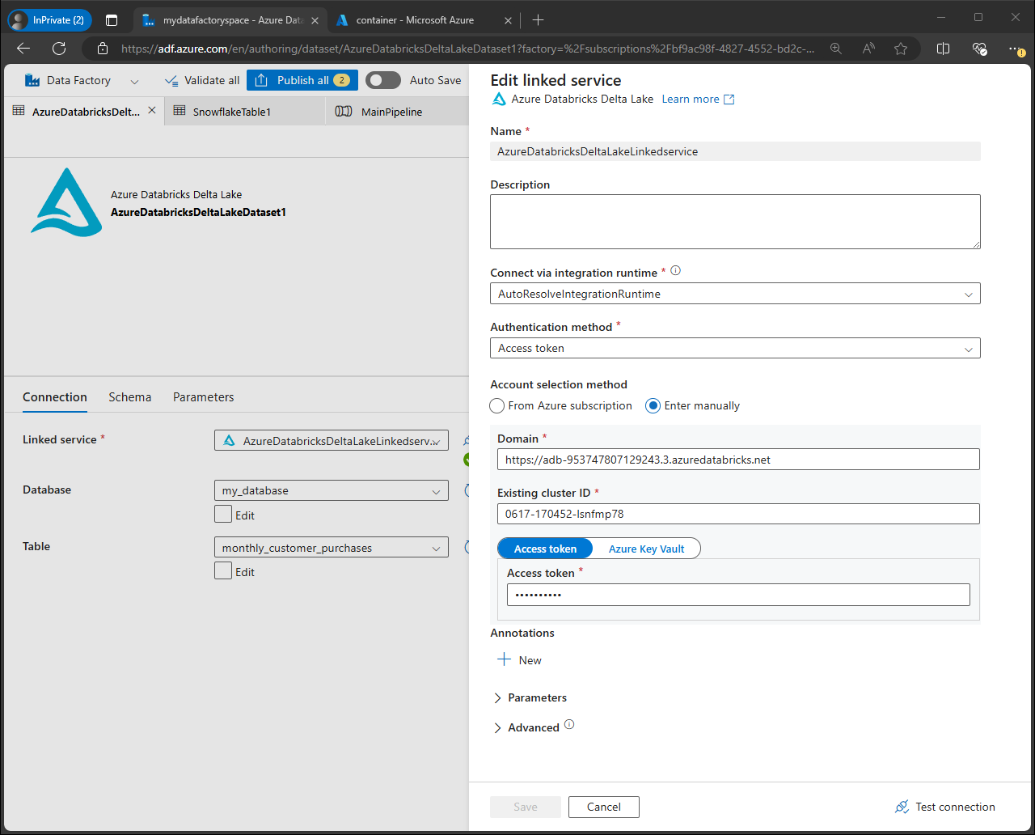

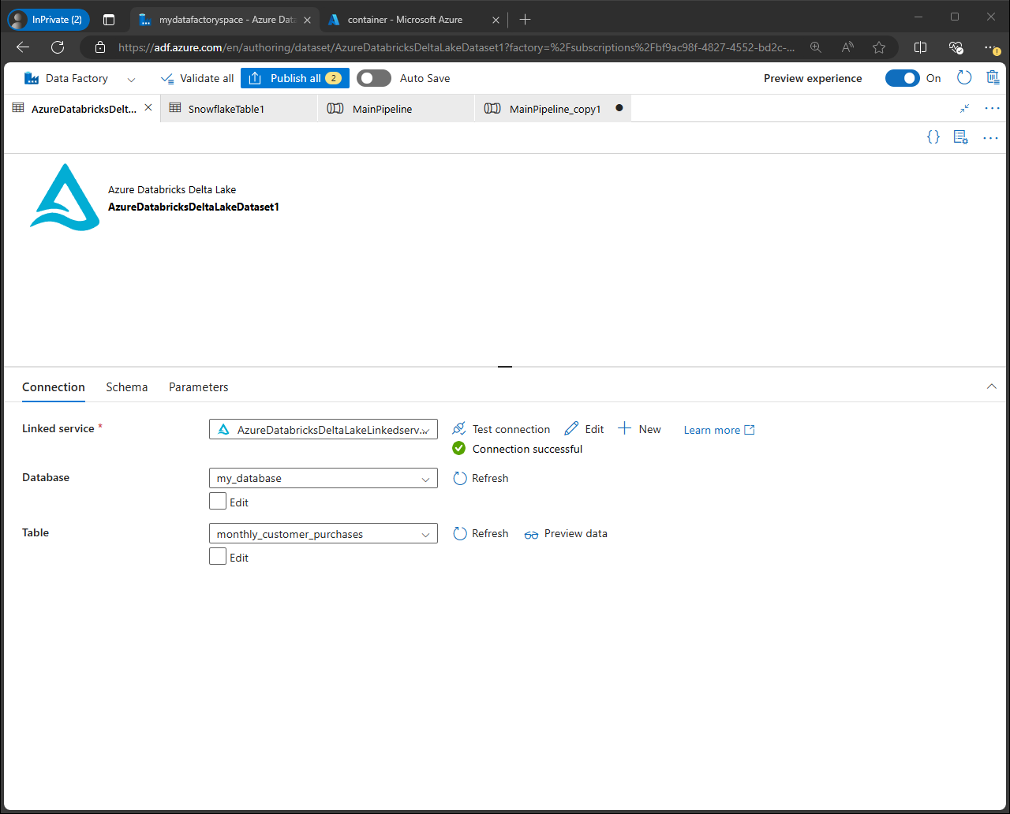

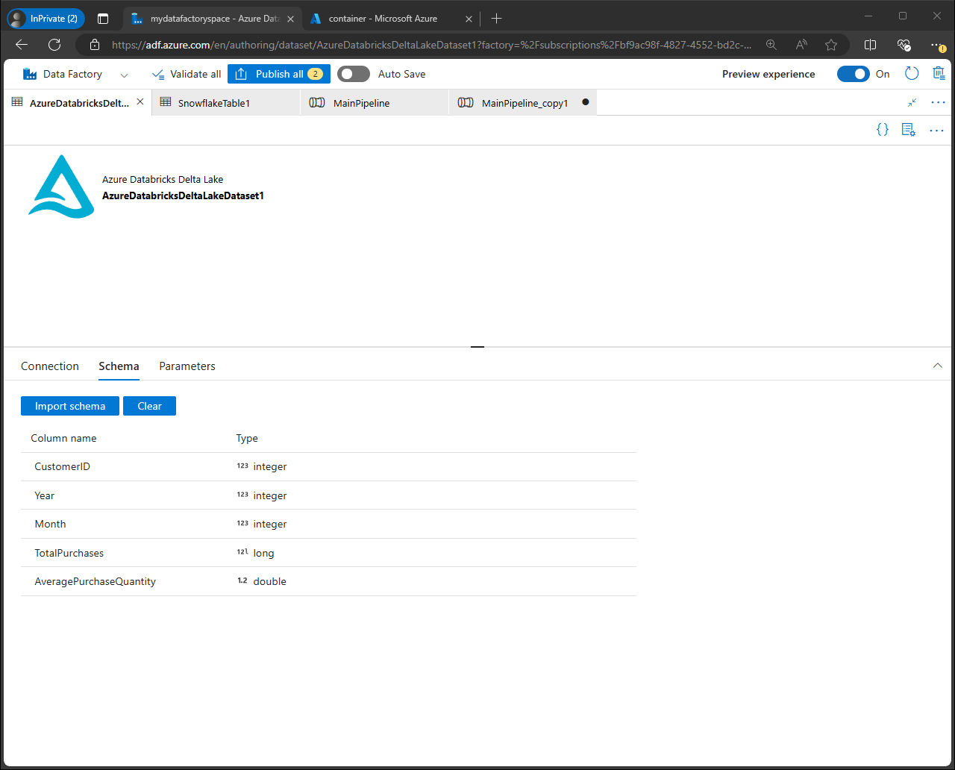

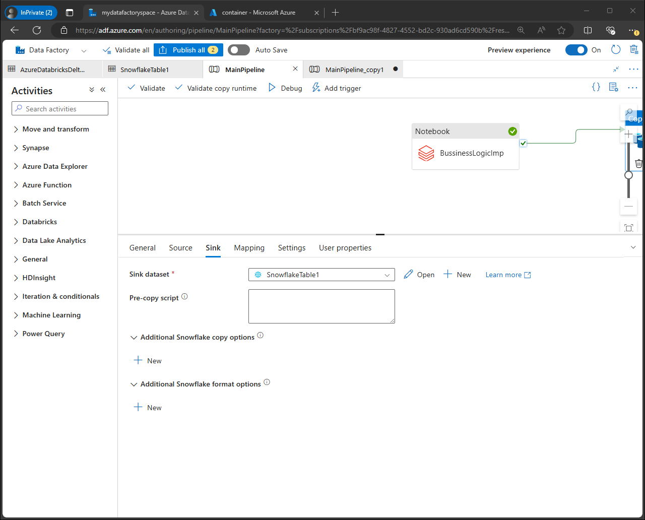

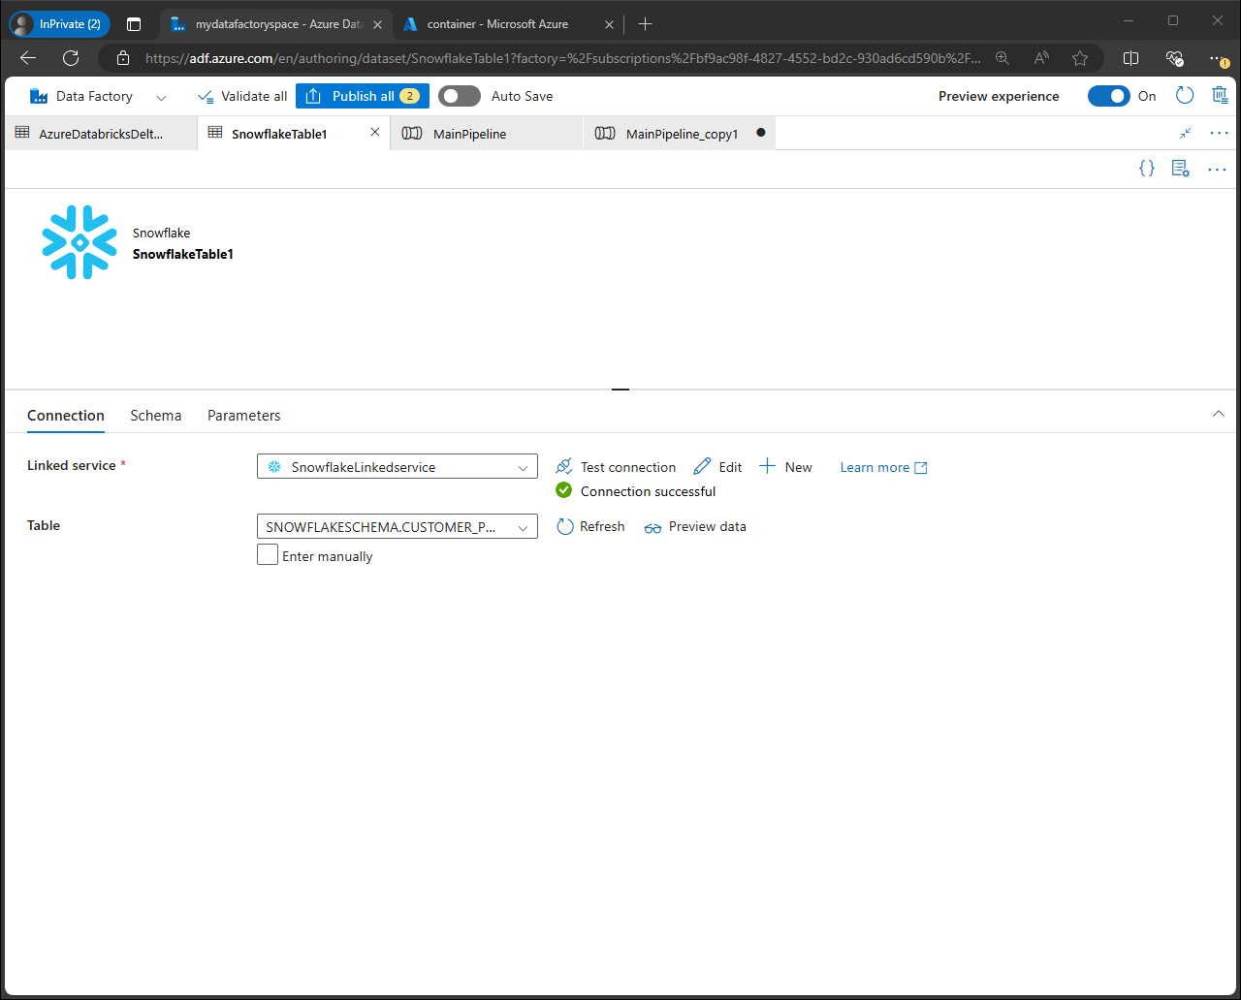

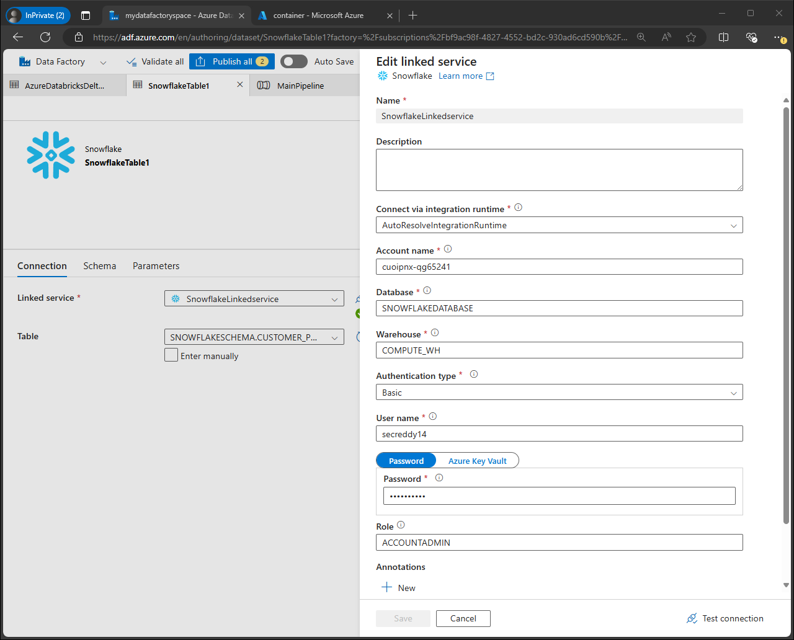

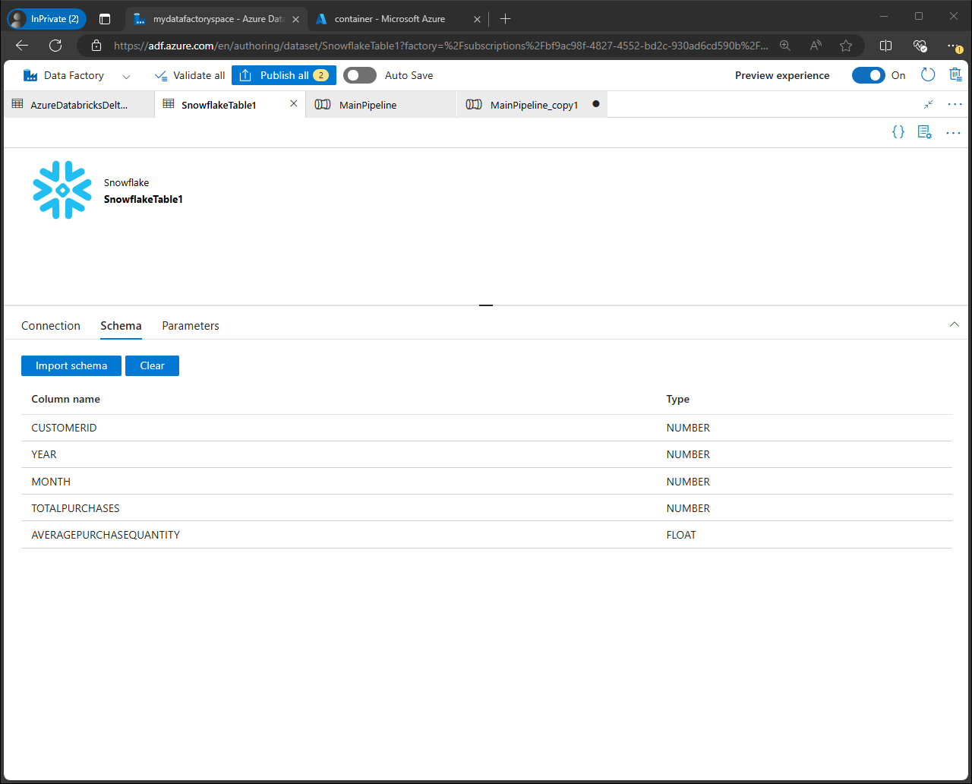

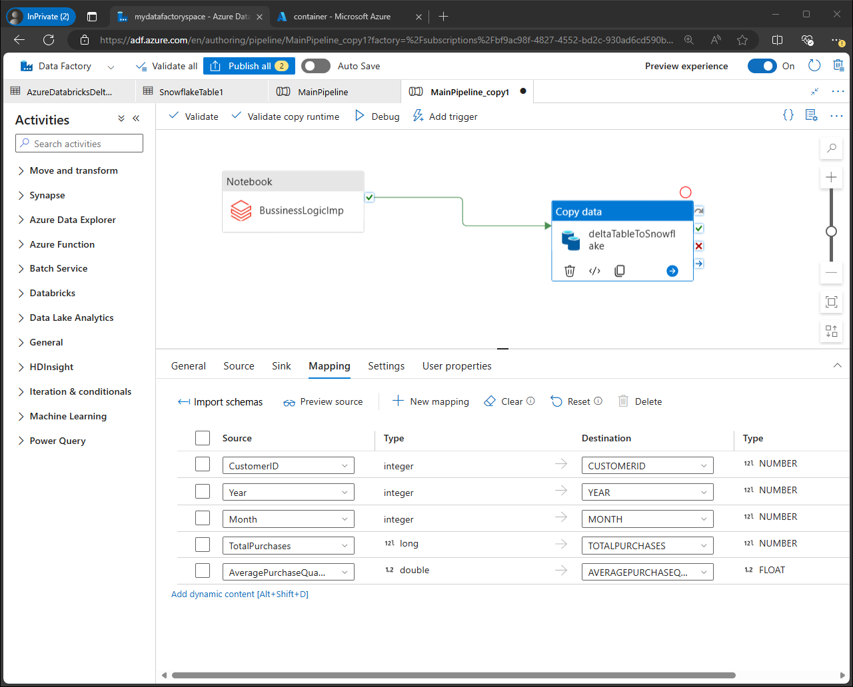

The above tried approach is loading the data directly from delta lake table (DATABRICKS) to snowflake in data factory using linked services (SAS URL)

Alternative approach to load the data from blob storage(csv) to snowflake

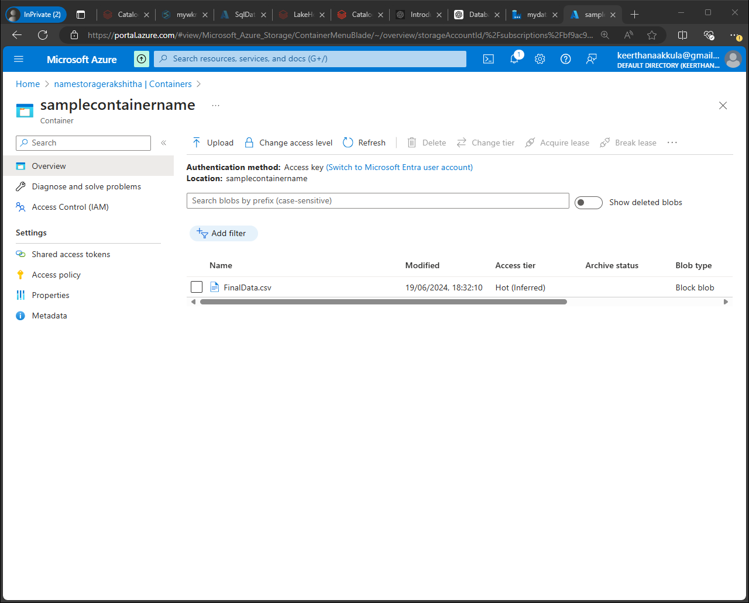

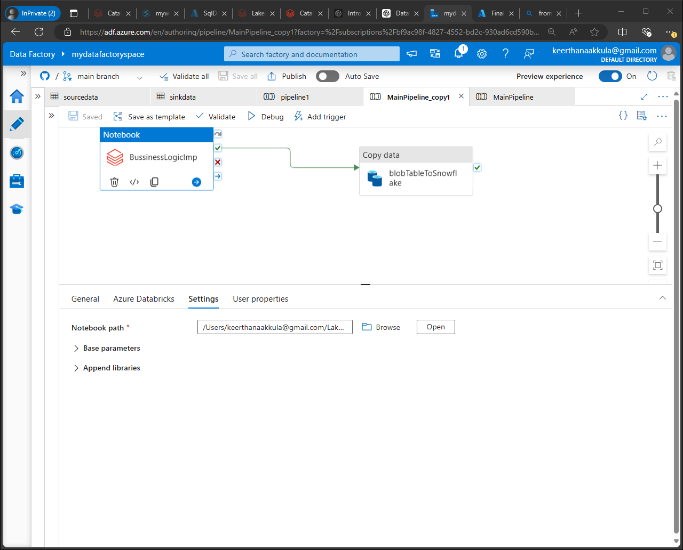

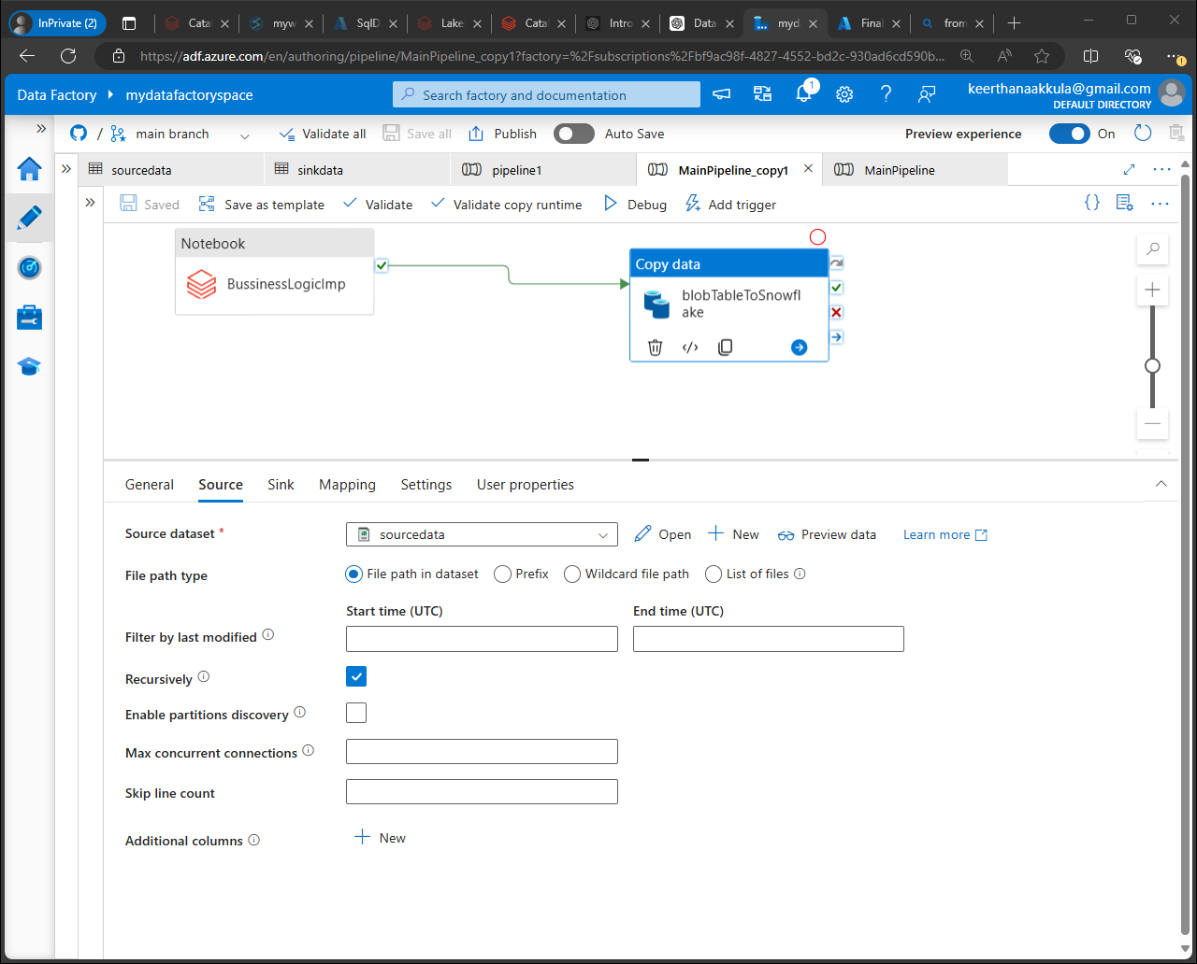

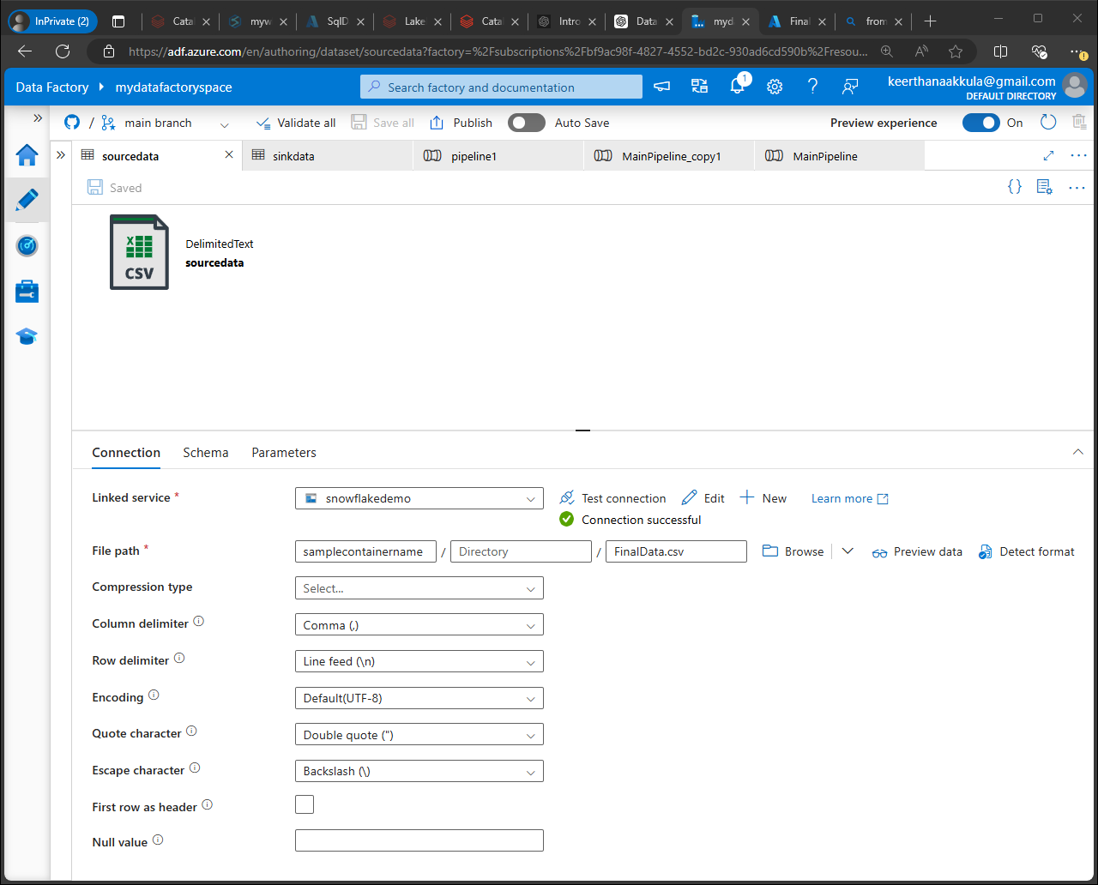

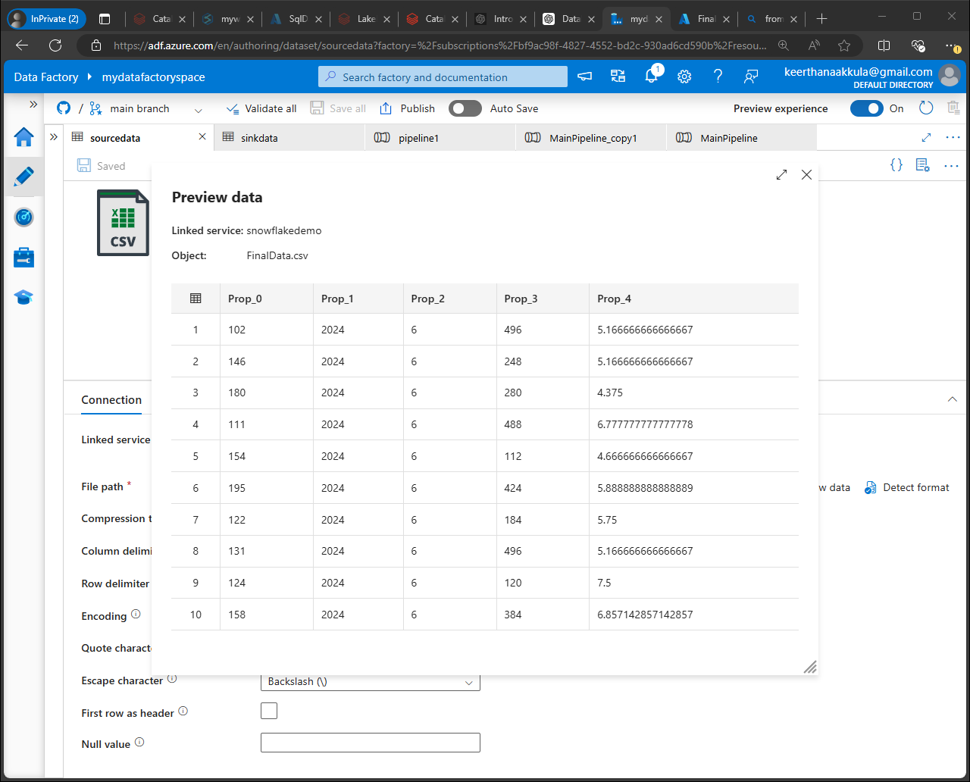

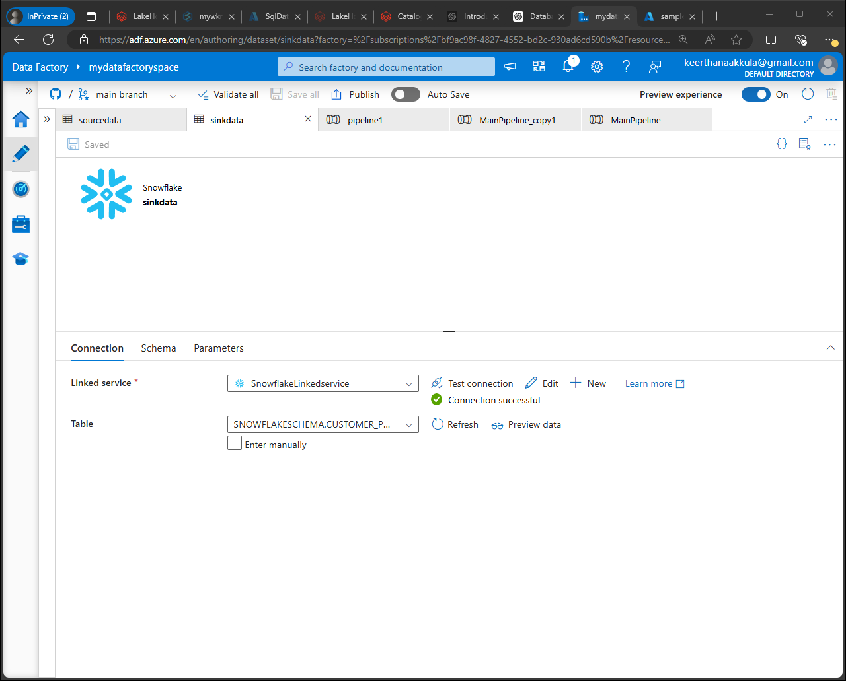

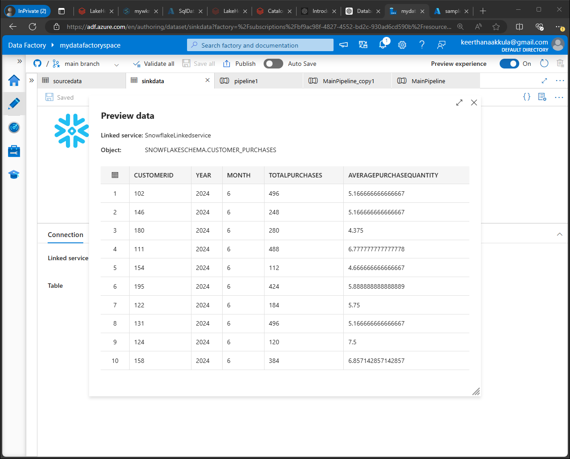

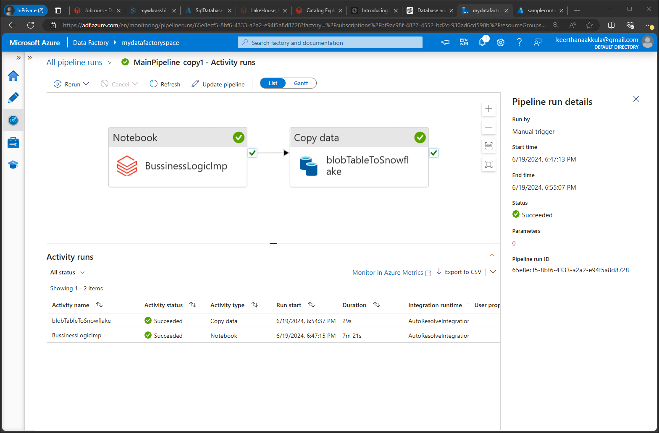

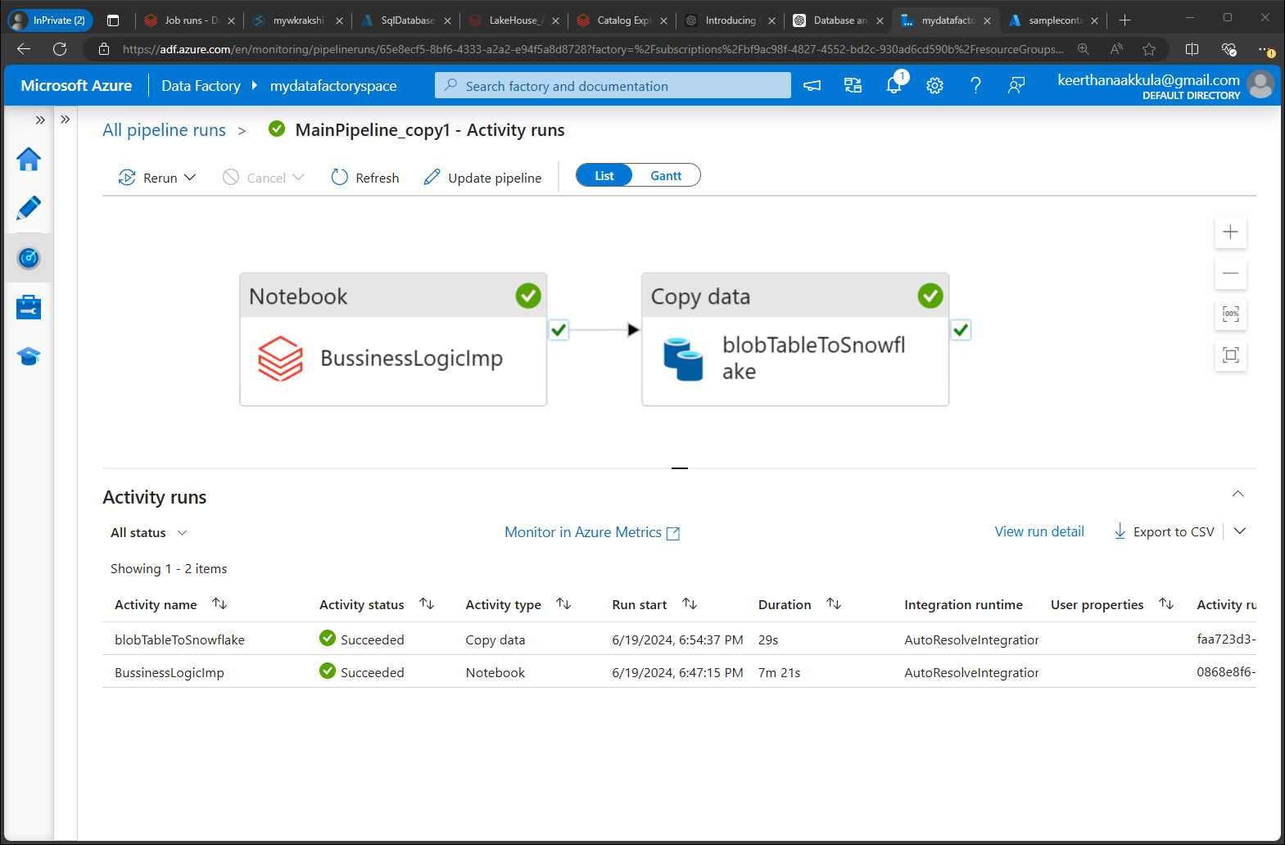

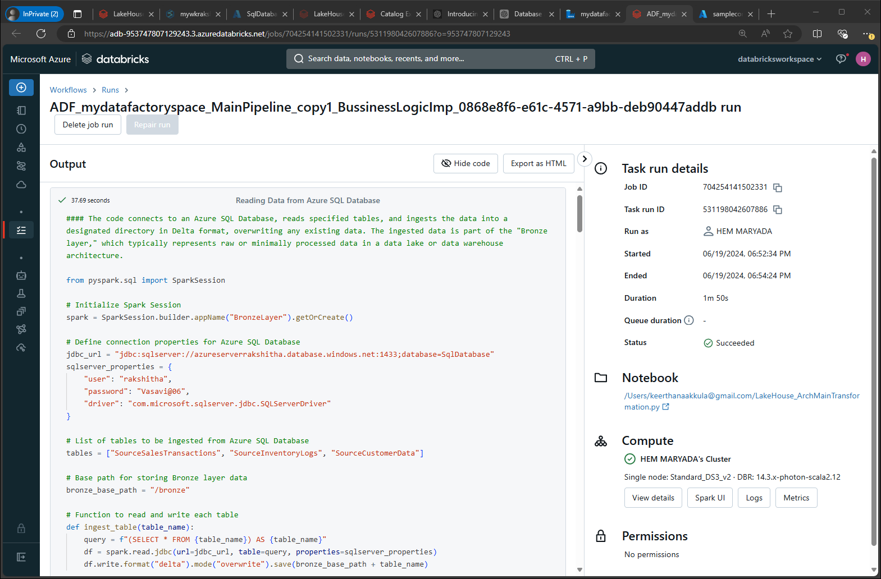

Count: 100

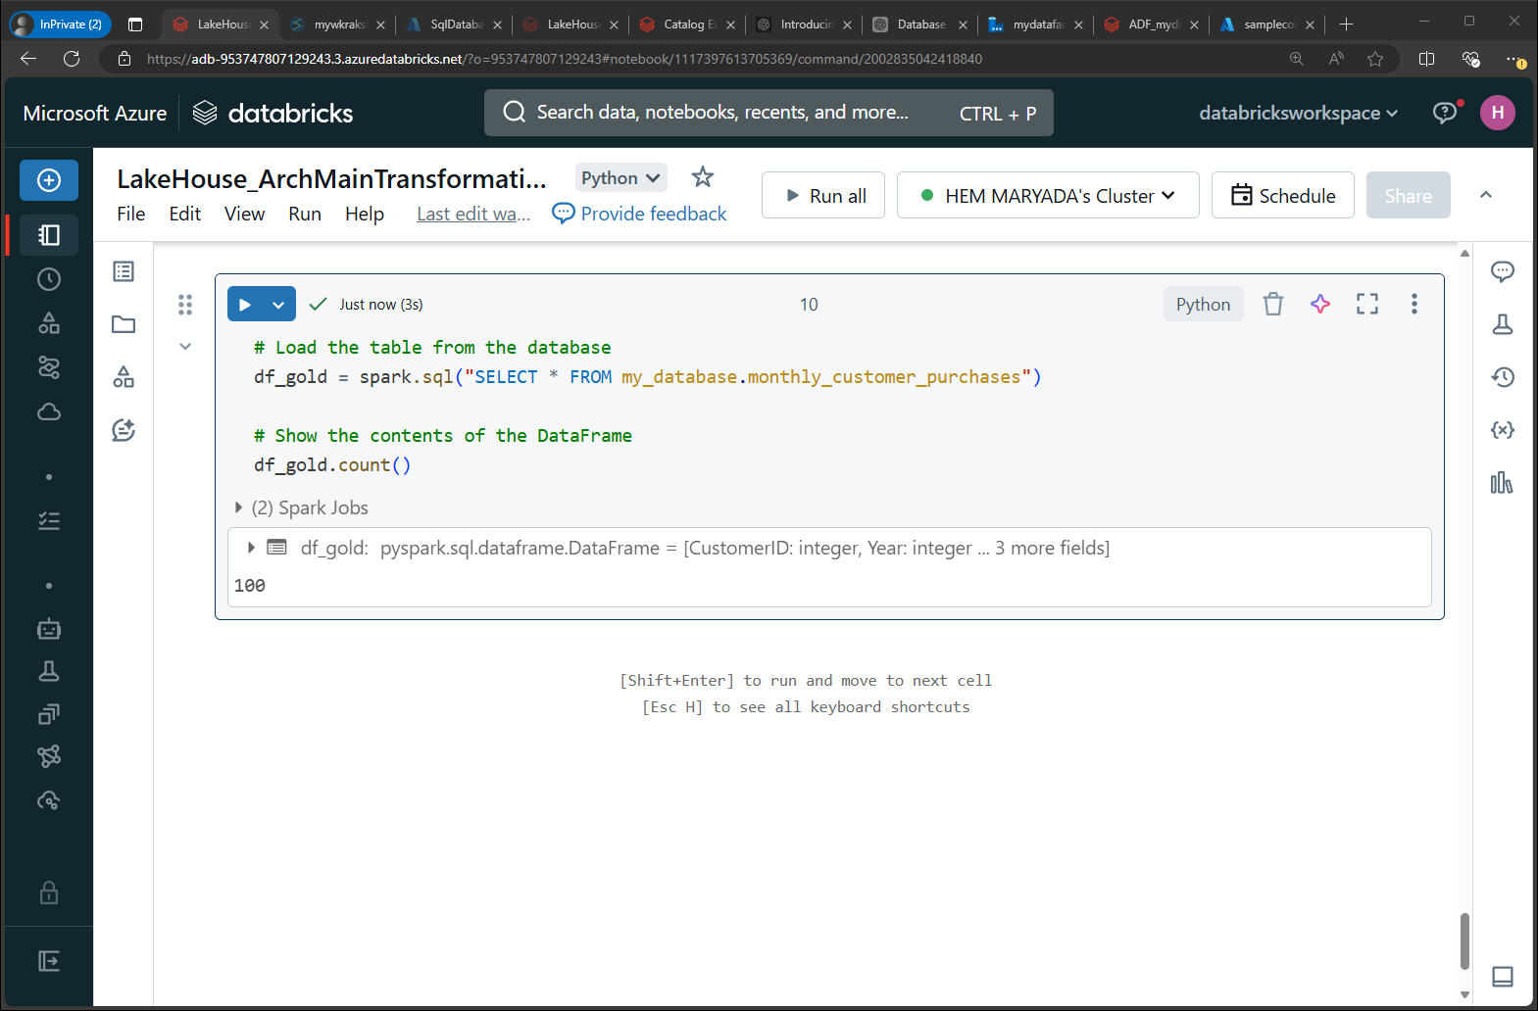

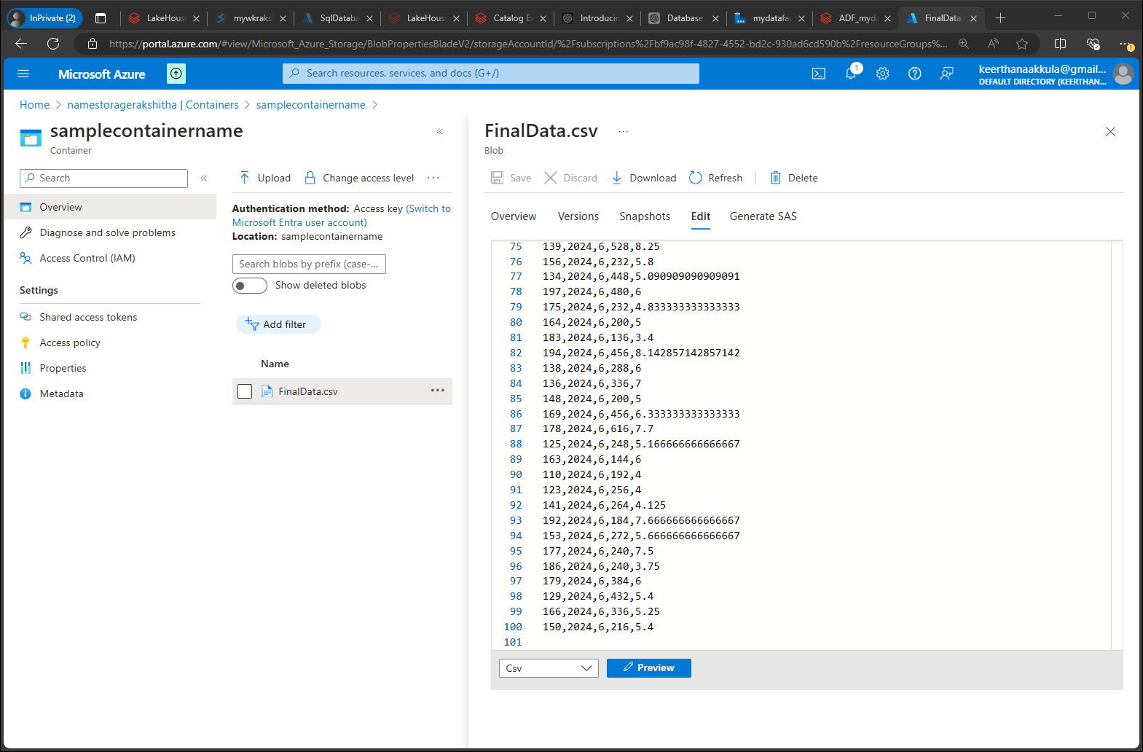

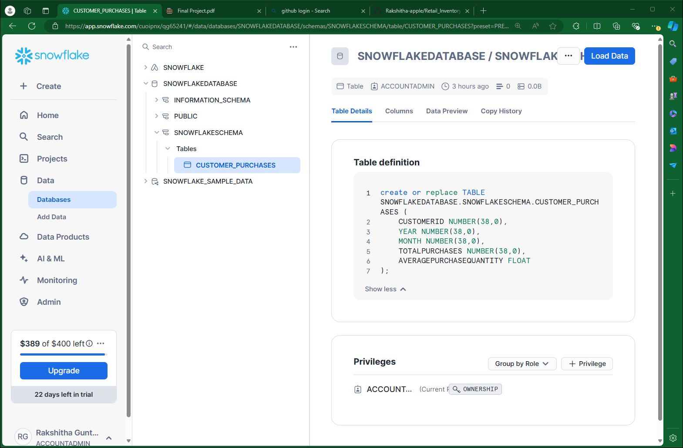

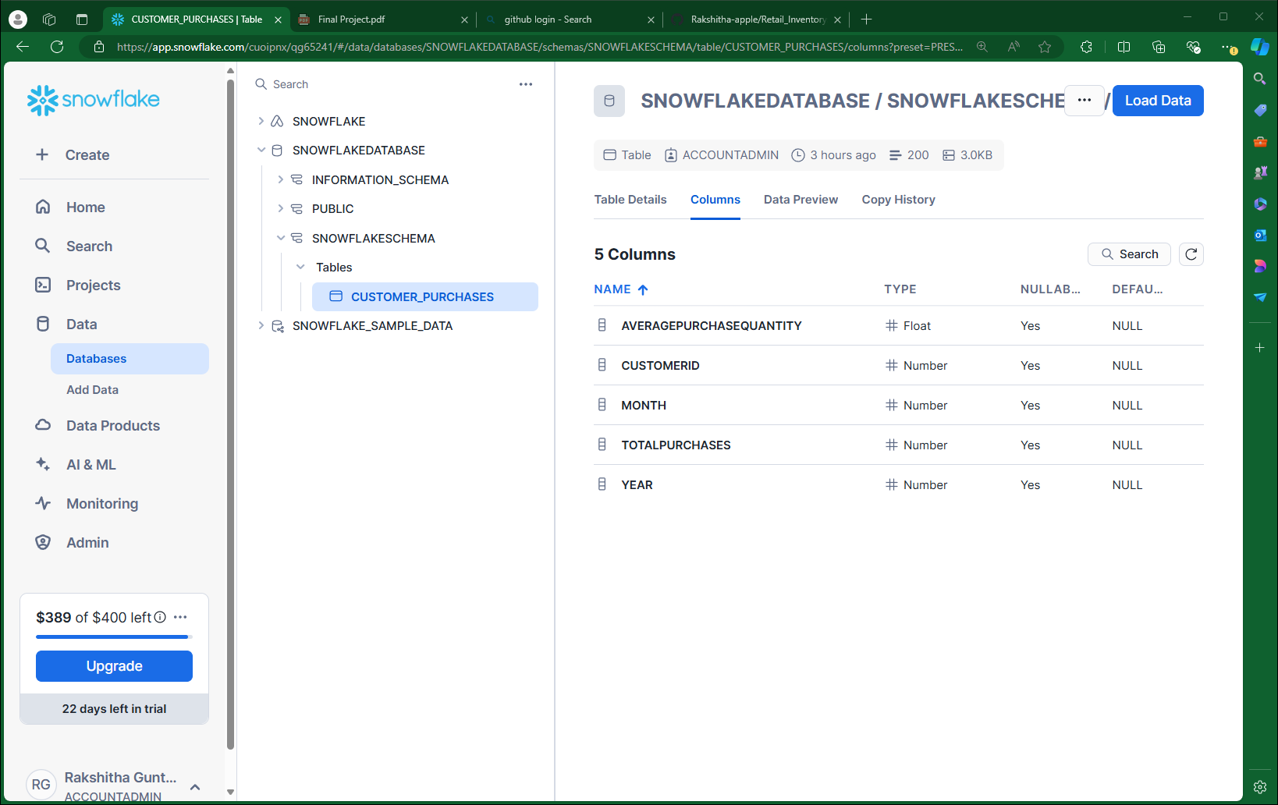

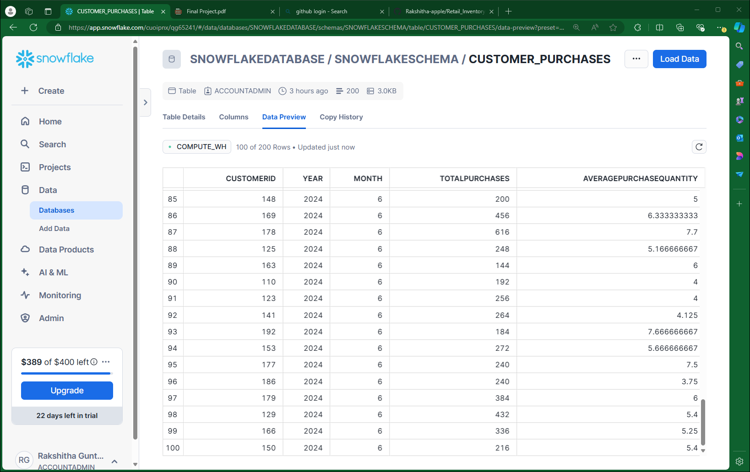

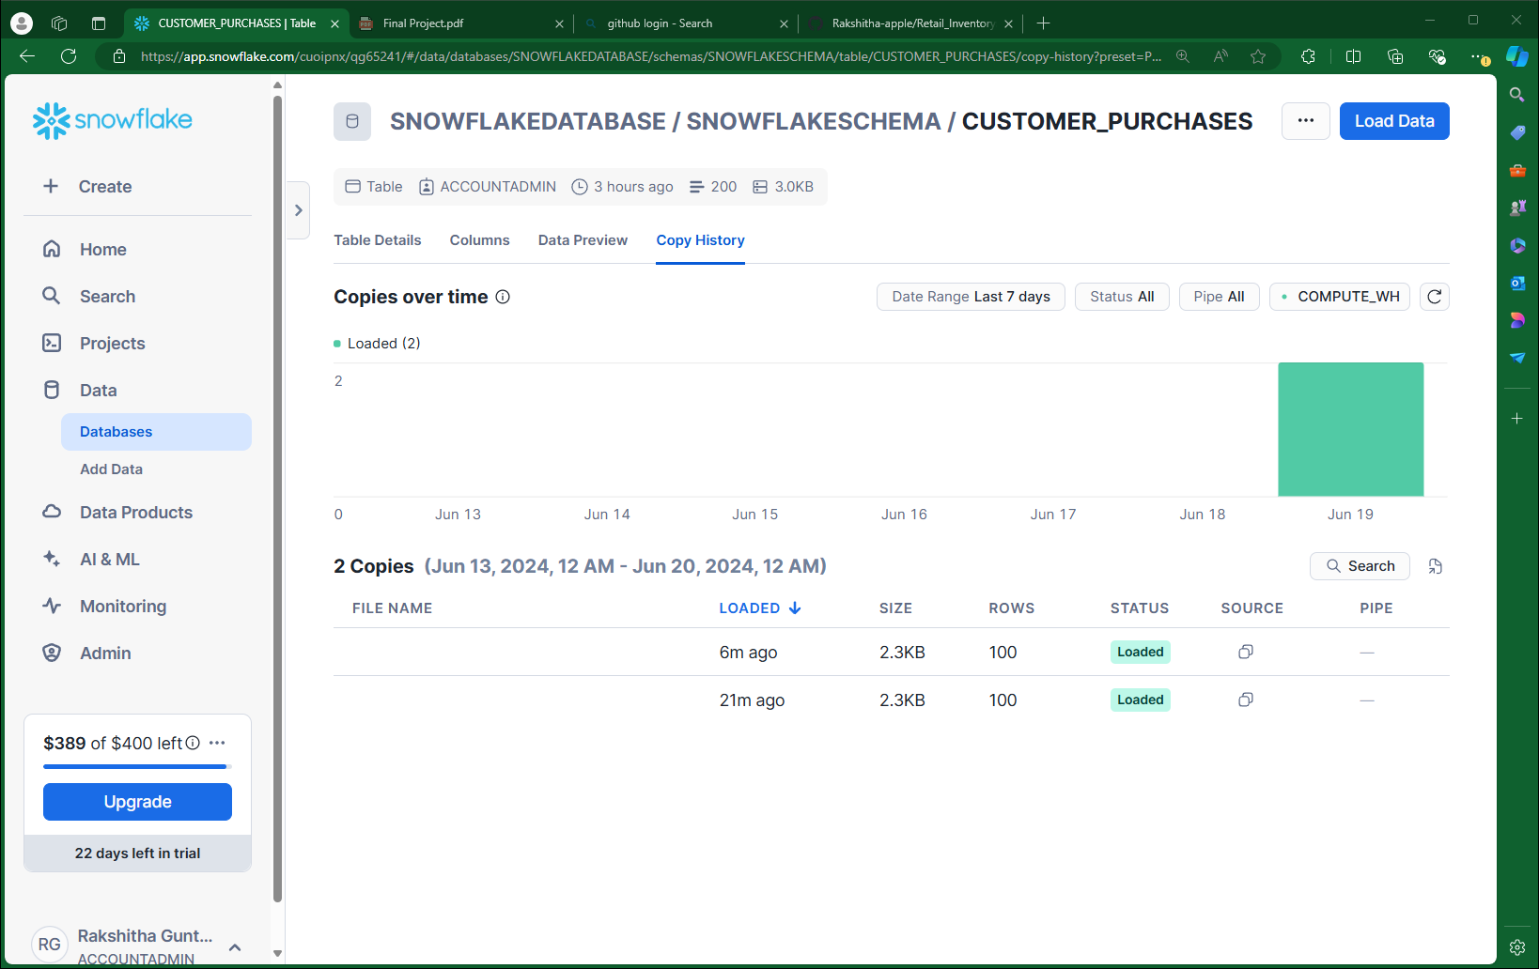

**Snowflake to Power BI Desktop**

**Server name of snowflake Accountname.region.snowflakecomputing.com**

**ai16587.canada-central.azure.snowflakecomputing.com**

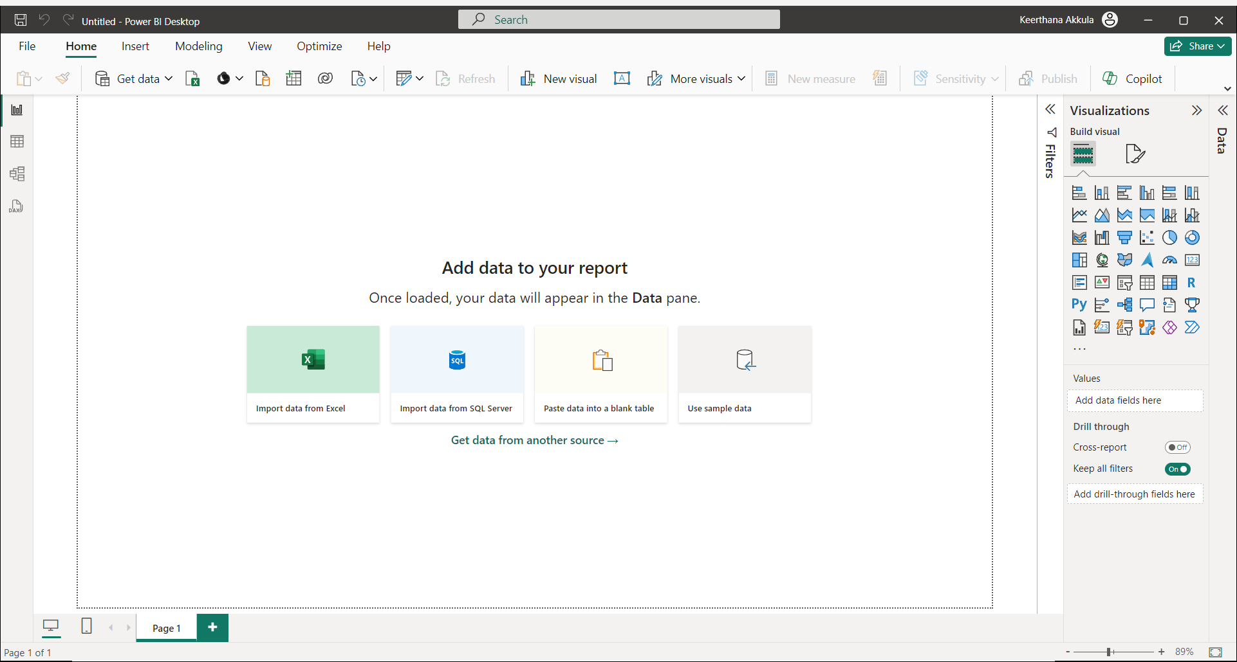

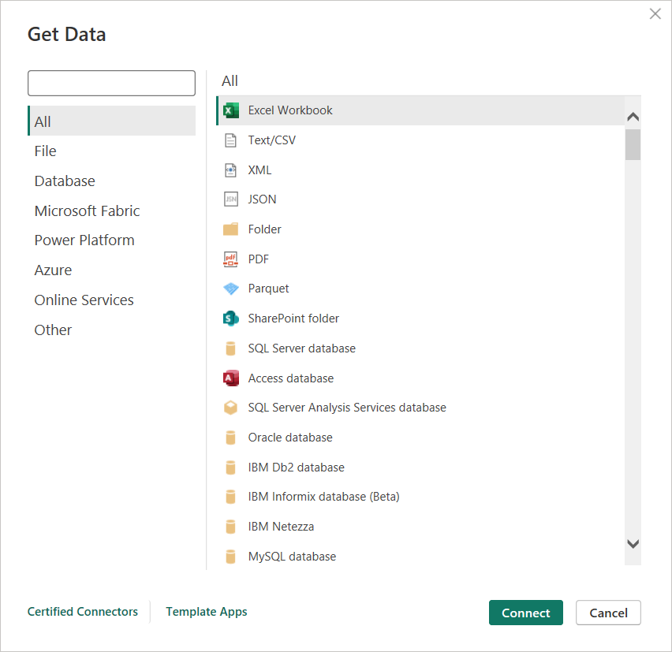

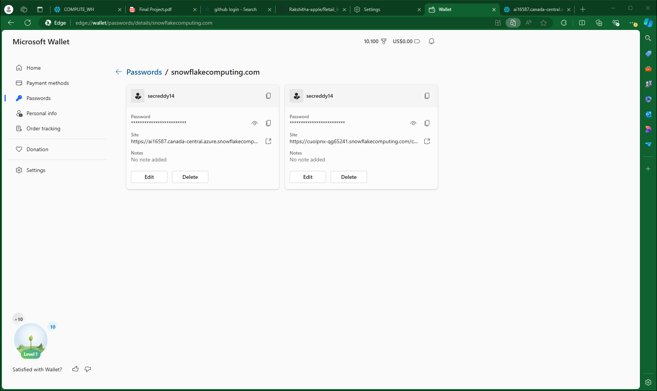

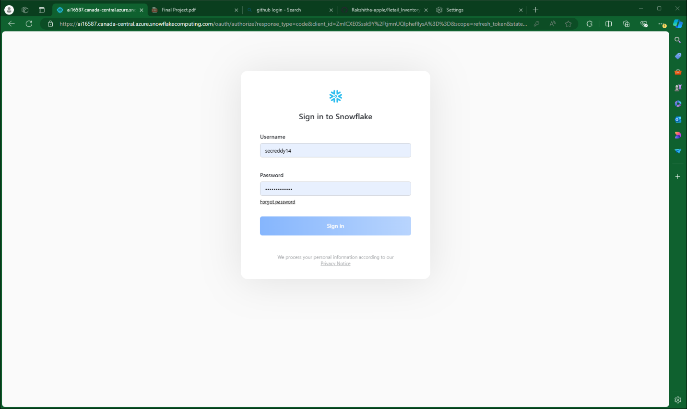

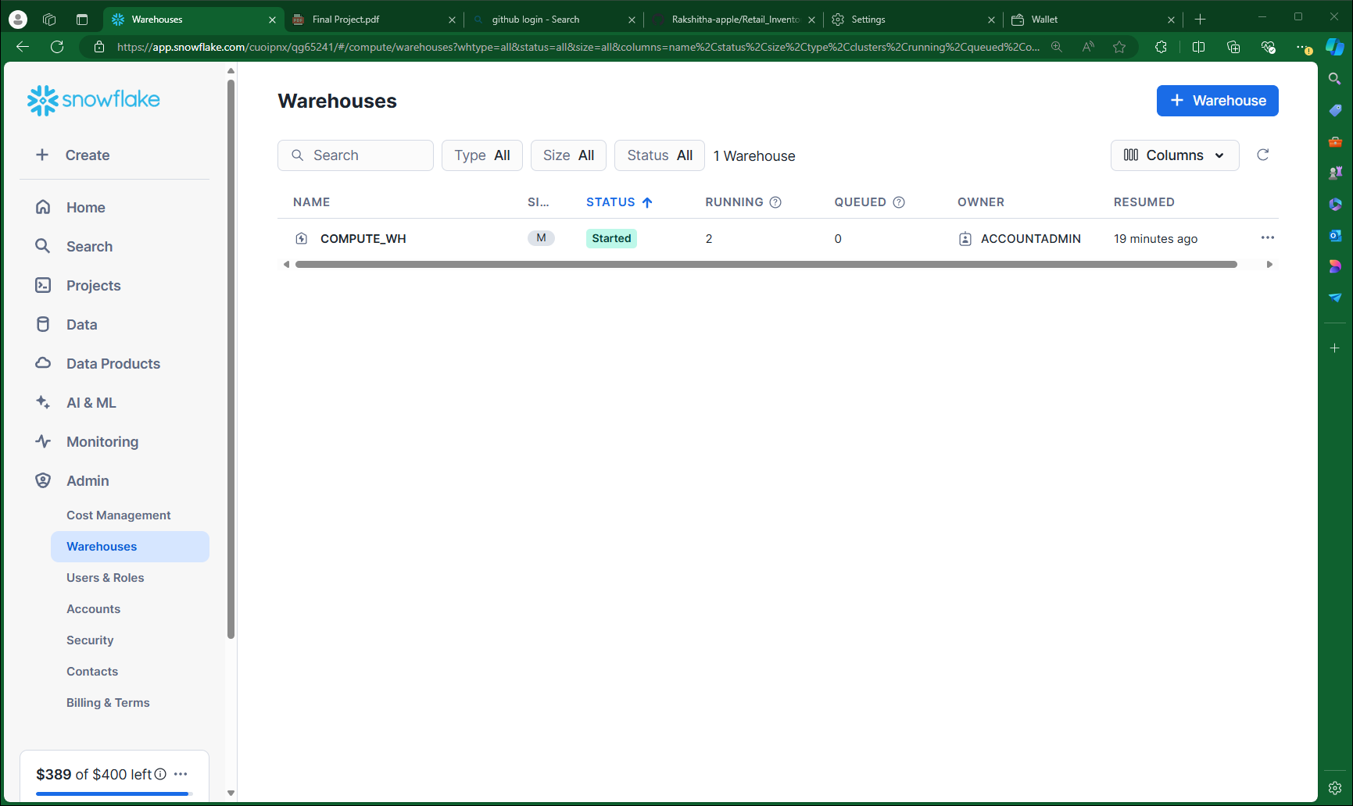

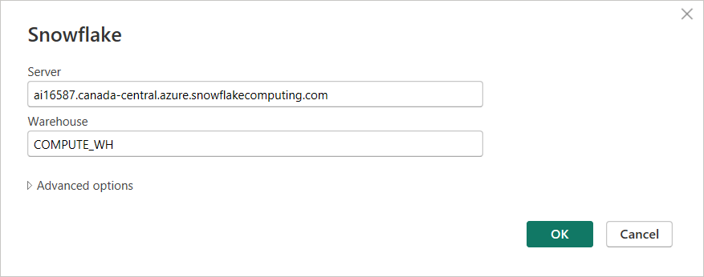

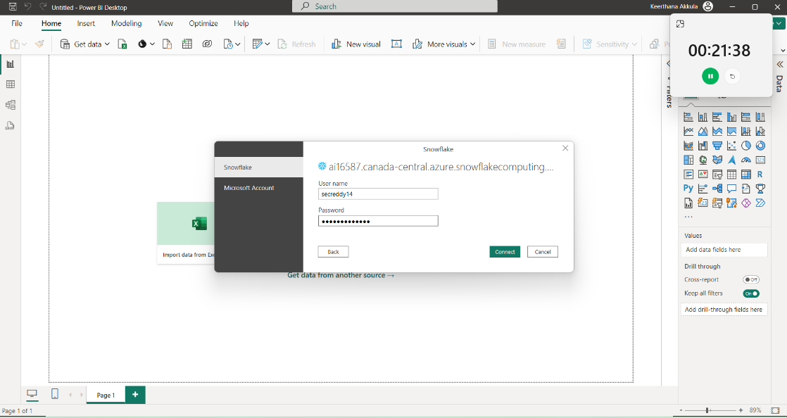

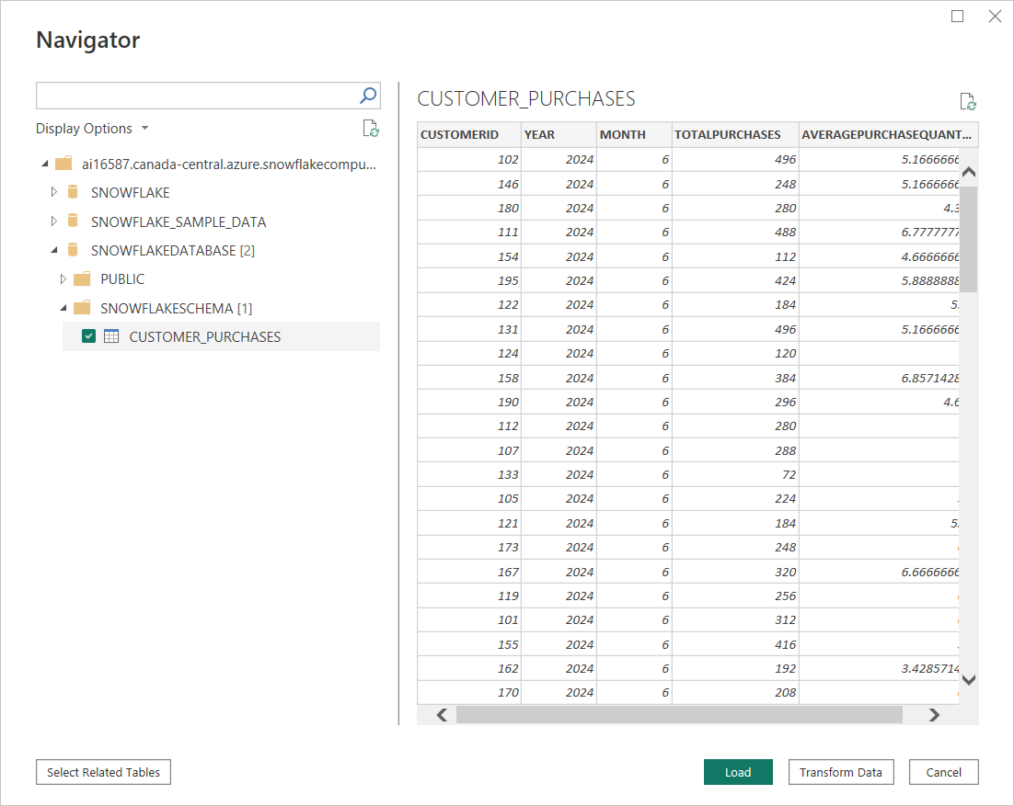

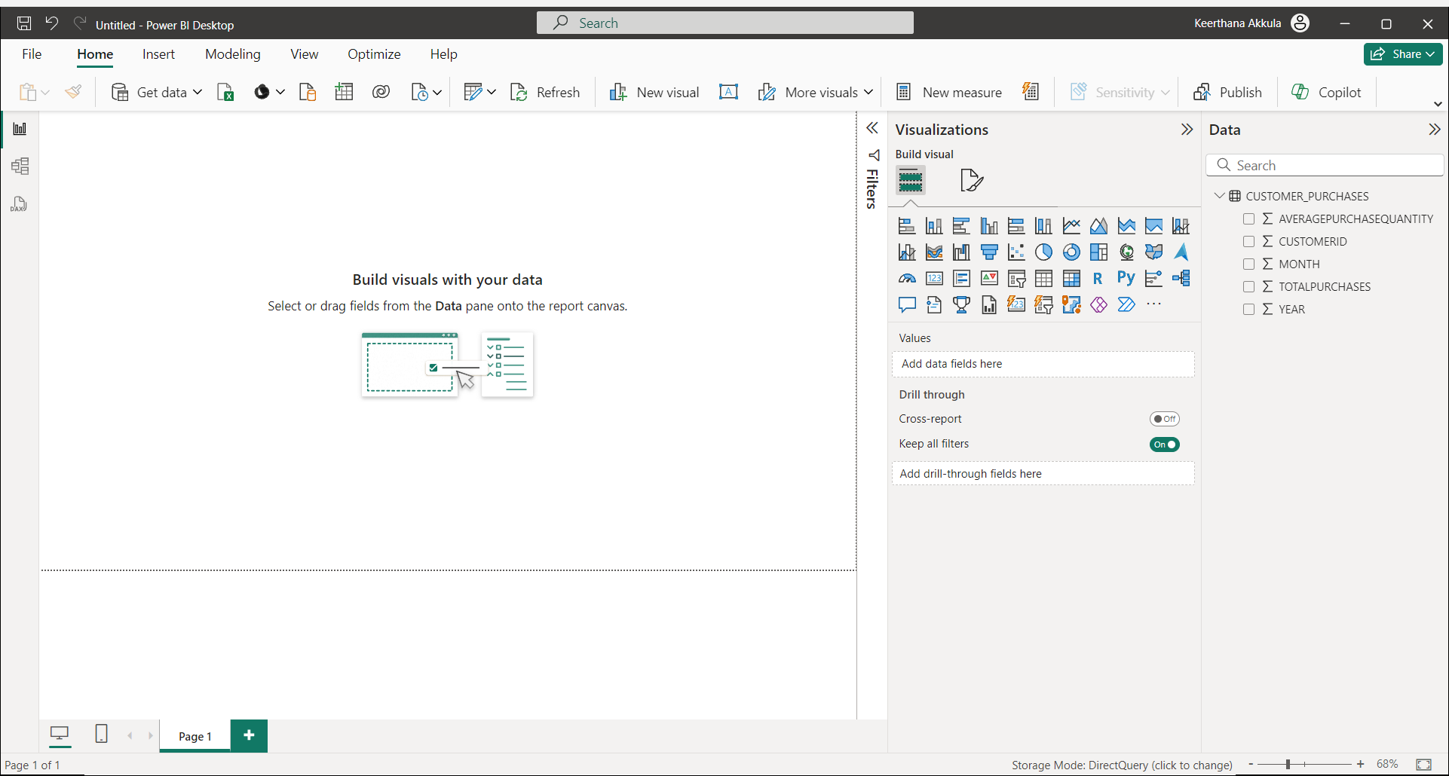

Used Pie chart, Tabular, Donut chart, Line chart

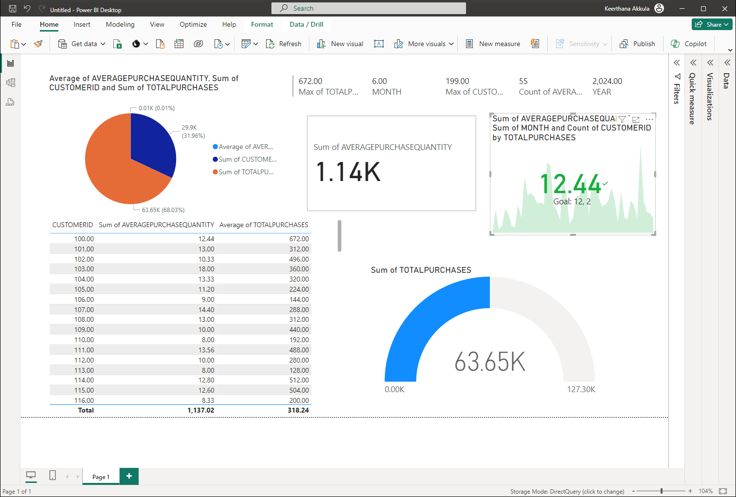

**Data Format Exploration:**

* **Experiment with different data formats (CSV vs. Parquet) and compare processing efficiency.**
* **Parquet offers better compression and faster query performance for analytical workloads.**

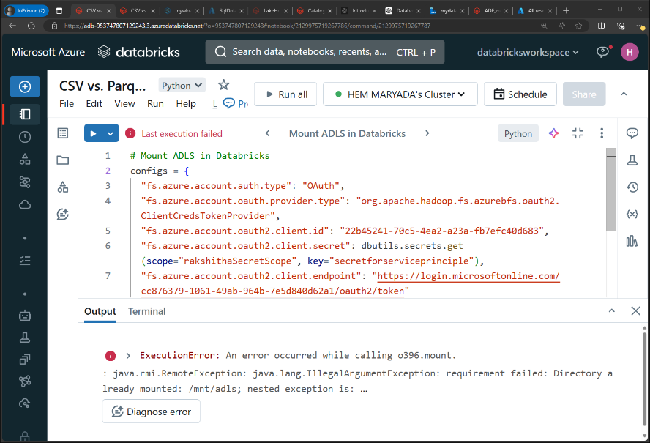

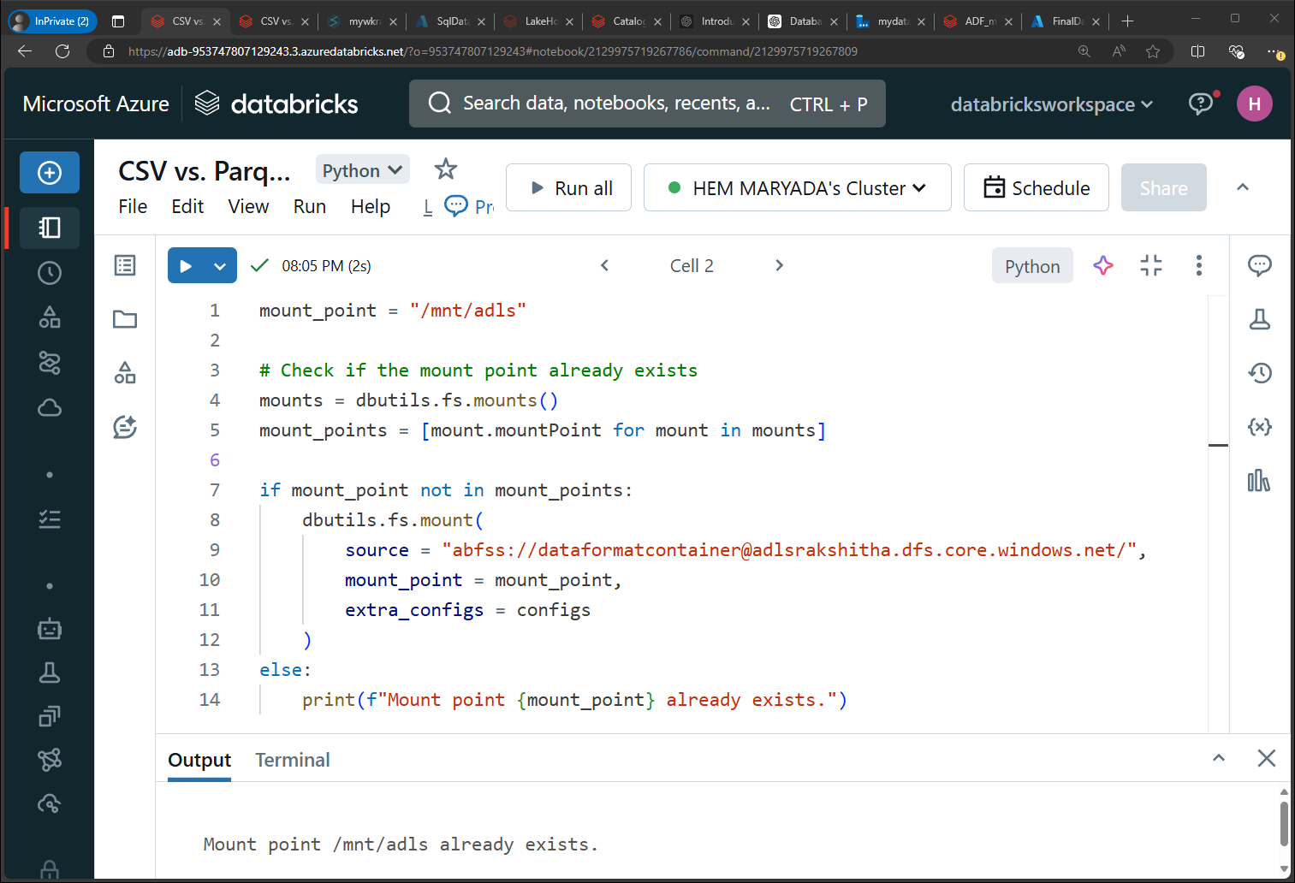

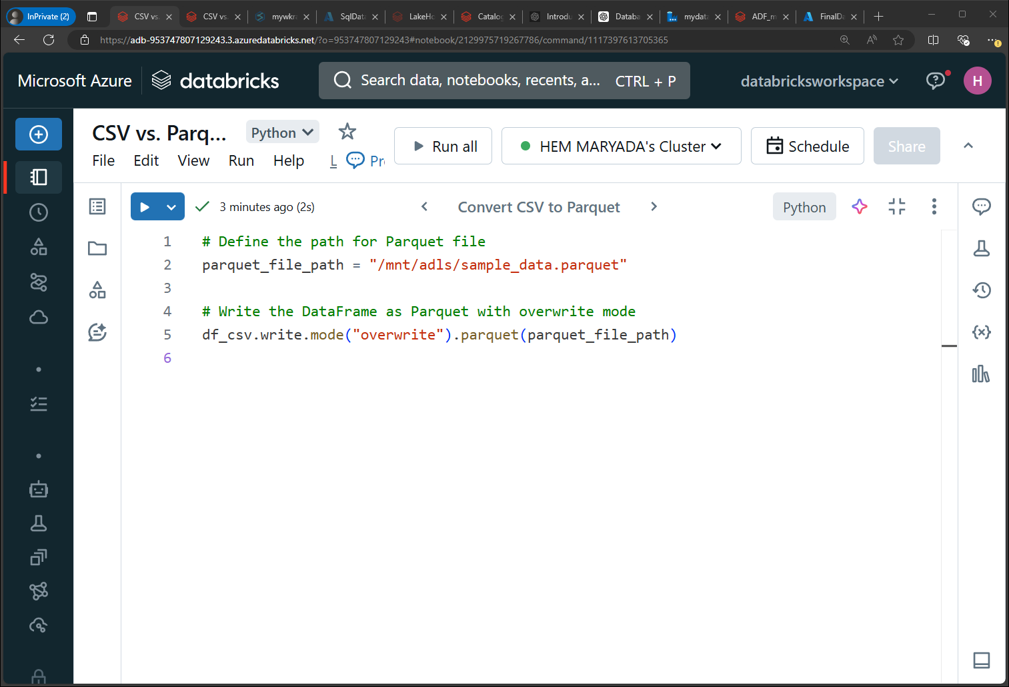

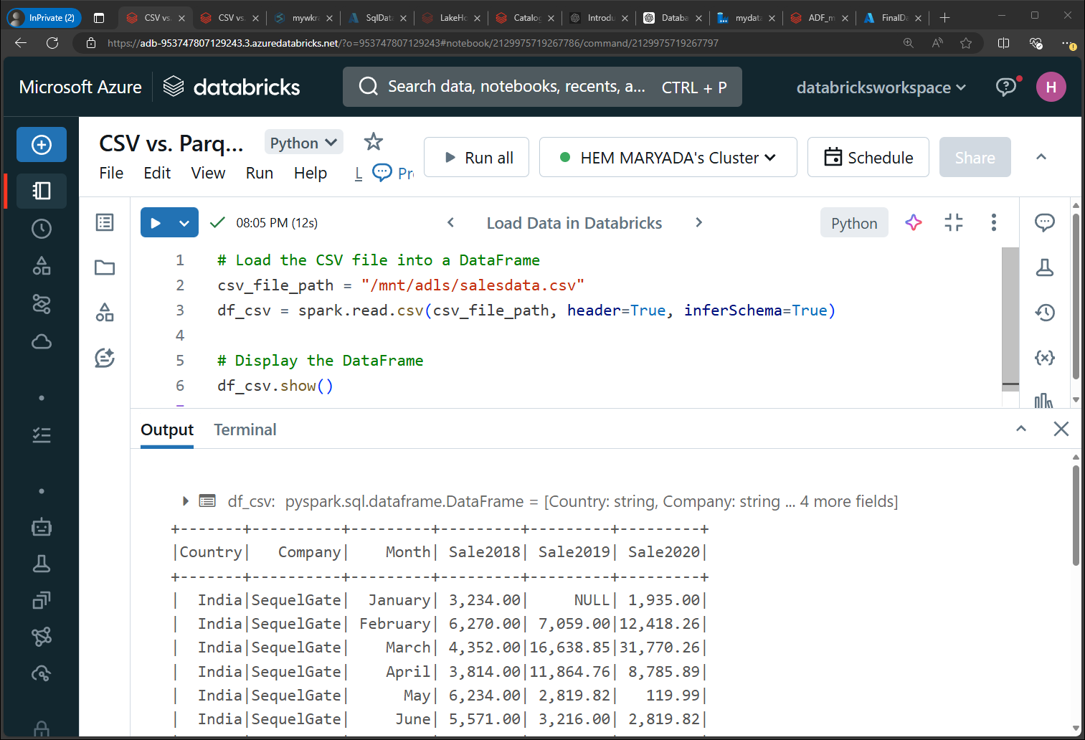

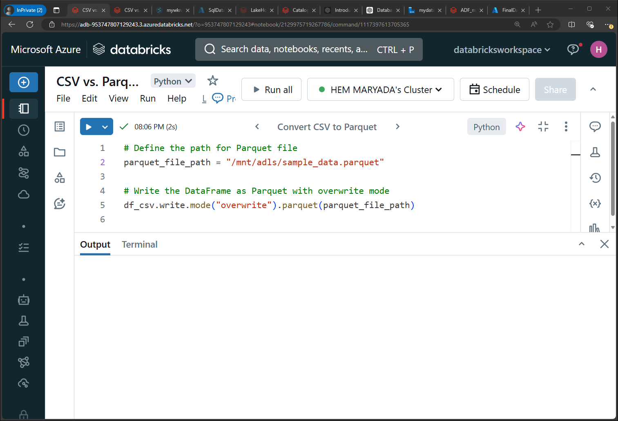

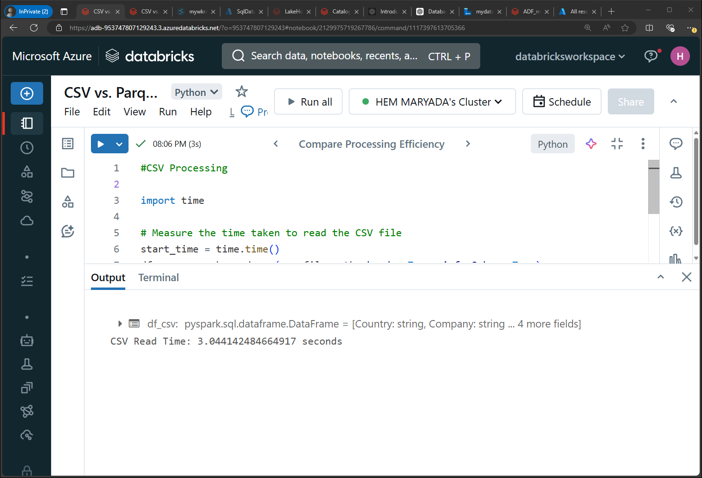

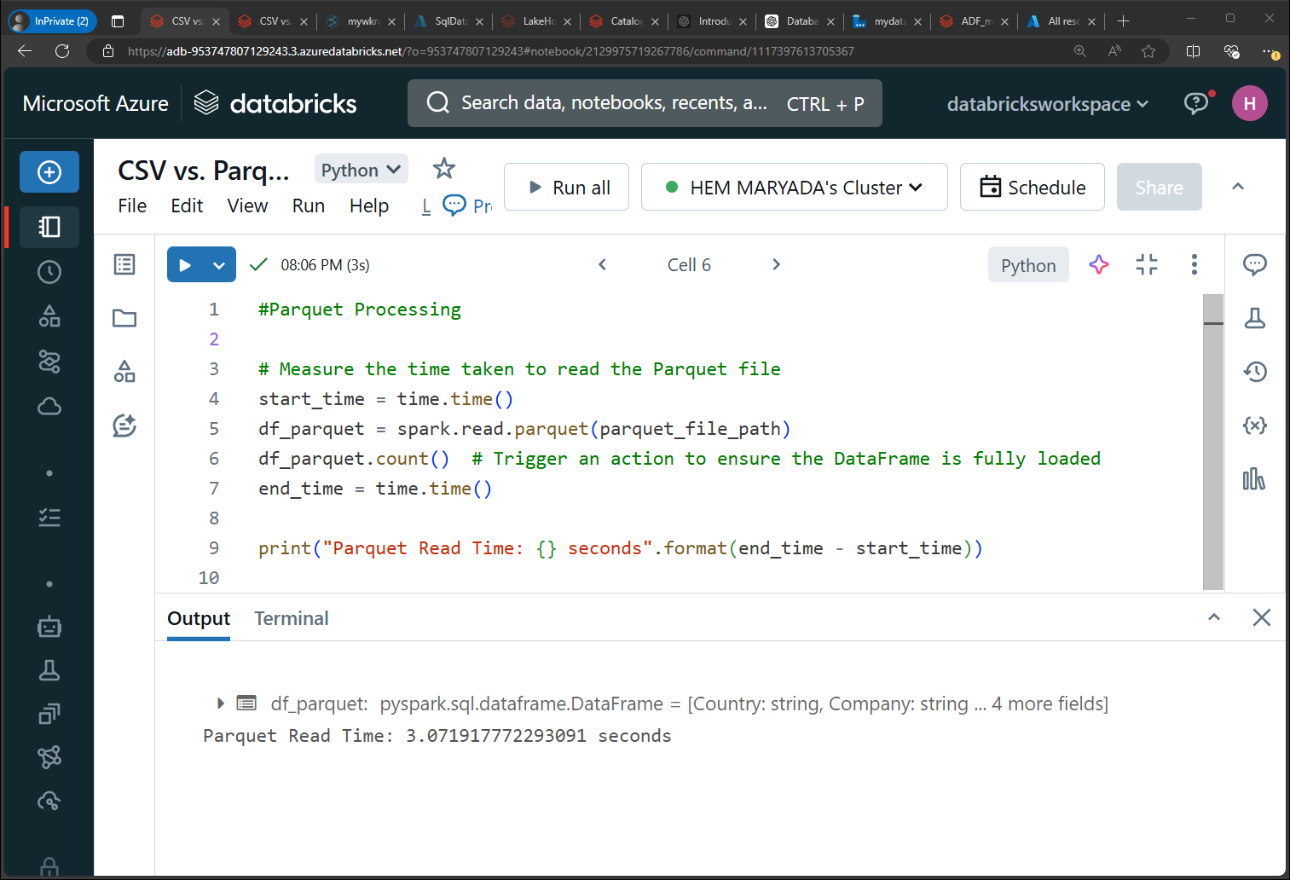

**The reason why the reading a CSV file takes less time than parquet file is because of the size of the file we are reading. Make sure we have the same file size to see the time difference between both of comparisons.**

**Overview of project –** Optimized the inventory management and improved the sales forecasting accuracy. I have achieved this by analyzing data from sales transactions, inventory logs, and customer information. There are 4 phases in my project

**Question 1: Why synapse to relational data base (Azure SQL DB)**? A retail company wants to analyze customer behavior to improve its marketing strategies. They have a data warehouse that stores massive amounts of historical sales, customer interactions, and product data. However, for more focused and faster analysis, they need to transfer specific subsets of this data to a relational database and then perform ETL operations on this data.

**Simplified form**

They have lots of historical data stored in a data warehouse. To analyze this data more quickly and easily we will transfer specific parts of it to a relational database and then perform ETL.

Aggregated data in warehouse (history data and aggregated data)

**Question 2: Delta to snowflake?**

1. Set up a Delta Lake to Snowflake integration using manifest files and query Delta tables.

2. Implement delta sharing in Databricks to Snowflake direct connect

3. Databricks provides a Snowflake connector in the Databricks Runtime to support writing data from Snowflake.

4. Pipeline should also work (delta table to snowflake)

https://community.databricks.com/t5/data-engineering/how-do-we-use-delta-sharing-between-databricks-to-snowflake/td-p/55415#:~:text=To%20implement%20delta%20sharing%20in%20Databricks%20to%20Snowflake,users%20who%20have%20access%20to%20delta%20sharing.%20

https://docs.databricks.com/en/data-sharing/index.html

<https://docs.databricks.com/en/connect/external-systems/snowflake.html>

**Direct delta to snowflake is not recommended because it is not a real time scenario – so what ever I used blob to snowflake is a real time case.**

**Question 3: How can you get the data stored in silver or bronze layer ?**

Table name and the connection where you want to write the data

Mounting in ADLS (Azure Data Lake Storage) and Databricks means connecting a storage account to Databricks so you can access the data stored in ADLS directly from Databricks as if it were part of your local file system. This simplifies data access and management within your Databricks environment.

**In simpler form**

Mounting in ADLS and Databricks means linking your data storage to Databricks so you can easily access and use your data stored in Azure within Databricks, just like you would with local files on your computer.

**And why do you use access key, sas key, iam ?**

Access keys (or SAS keys) are used in Azure services like Azure Data Lake Storage (ADLS) and Databricks for authentication and authorization purposes. Here's a simpler explanation:

Access keys or Shared Access Signature (SAS) keys are used to securely connect services like Azure Data Lake Storage (ADLS) to Databricks. They act like passwords, allowing Databricks to access and manage data stored in ADLS, ensuring secure and controlled access to your cloud storage resources.